Excellent circular economy in project business:
Kaldewei receives the German Sustainability Award 2026

KALDEWEI, Ahlen, January 2026 – In a pioneering renovation project, Kaldewei and the 25hours Hotel Bikini Berlin have demonstrated how circular economy can be successfully implemented in project business. The Westphalian premium bathroom manufacturer has now received the German Sustainability Award (DNP) 2026 for its extraordinary refurbishment concept. The award ceremony took place recently at the DNP Congress in Düsseldorf at the beginning of December.

The DNP recognises the synergy between product preparation and the circular economy, highlighting in particular Kaldewei's innovative combination of durability and product design in a market segment long dominated by the installation of new products.

“By refurbishing shower surfaces and bathtubs made of steel enamel, Kaldewei is redefining sustainable renovation in the project and commercial property sector and is sending a strong signal for a rethink in the construction and renovation industry,” summarised the jury led by Professor Dr Michael Braungart, who personally presented the award to a member of the Executive Board.

According to the jury’s statement, the project at 25hours Bikini Berlin exemplifies how industrial processes can be used to implement cradle-to-cradle principles on a large scale and establish new standards for sustainable modernisation.

Rather than disposing of the existing products during the modernisation process, they were dismantled, returned to the manufacturer and comprehensively refurbished in a multi-stage industrial process. They were then reused in the hotel as fully functional, high-quality refurbished products. Compared to manufacturing new products, this saved around 65 per cent of CO₂ emissions and conserved considerable amounts of primary raw materials.

“This award reinforces our conviction that sustainability is not an optional extra, but a fundamental part of our product philosophy,” explains Jakob Klingenberg, Key Account Manager Project Management at Kaldewei. “The project at the 25hours Hotel Bikini Berlin shows that the circular economy is already feasible today – economically, with high quality and with real added value for all involved.”

Bathtubs and Superplan shower surfaces from Kaldewei have been in use for over a decade at the 25hours Hotel Bikini Berlin. As part of the renovation, these were removed, sandblasted, re-enamelled and technically upgraded. With the slip-resistant KALDEWEI Secure Plus surface, the products were given an additional safety feature that benefits both hotel guests and the operator. The renovation is therefore also considered pioneering by the hotel management.

With the German Sustainability Award 2026, Kaldewei is once again highlighting its role as a pioneer in sustainable bathroom solutions and proving that durable steel enamel products need not reach the end of their service life after a first lifecycle, but can be optimised through upcycling and refurbishment to start a second phase of use. Kaldewei sees the project as a benchmark for the industry – and as a starting point for establishing circular economy principles more broadly in the sanitary and construction sectors in the future.

Further information and images can be found in the Kaldewei Press Centre at: https://www.kaldewei.co.uk/press/releases/

Images and caption:
1_KALDEWEI_DNP26
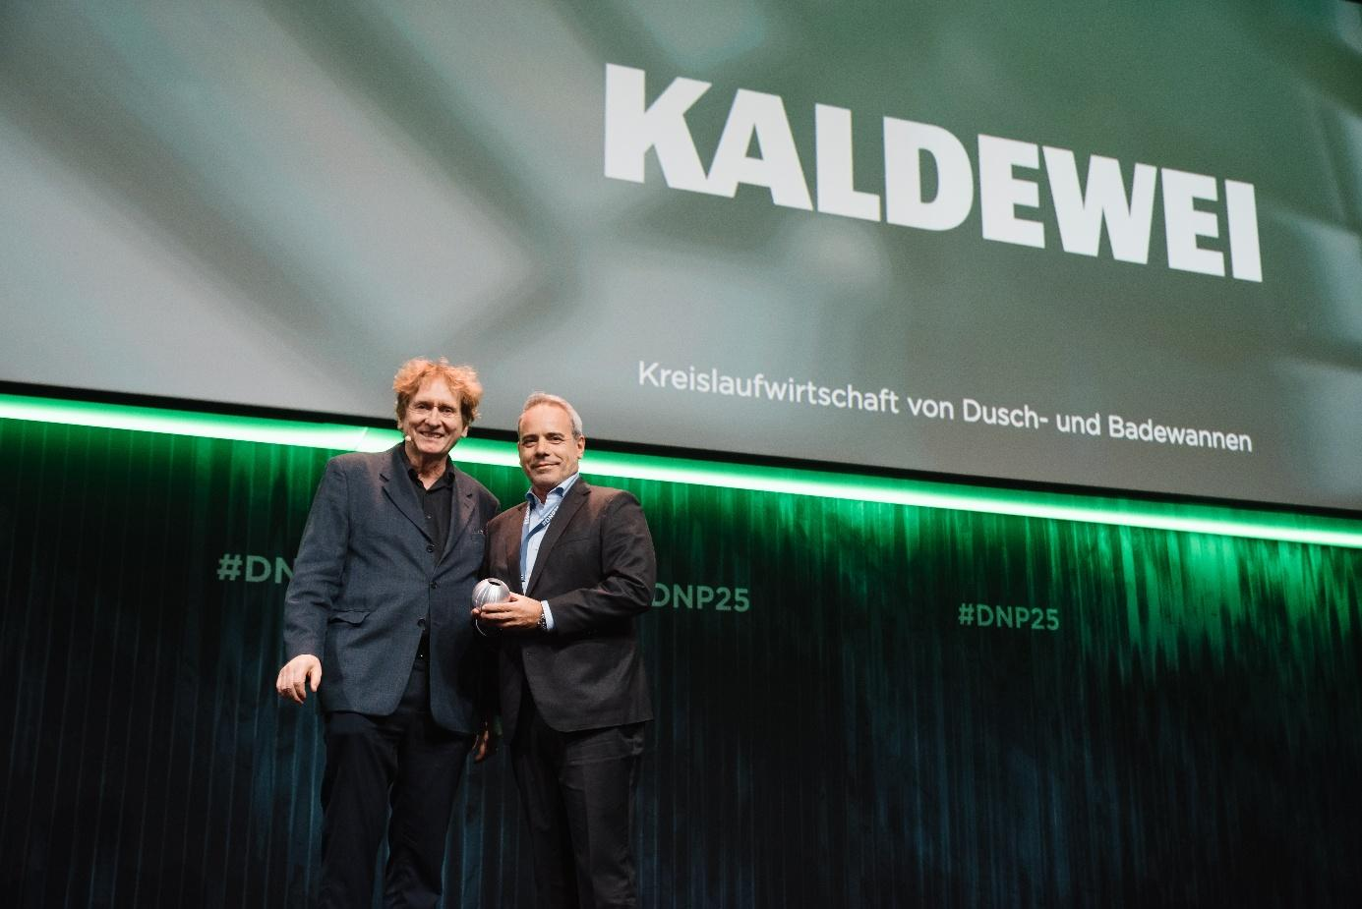
Photo: ©Dariusz Misztal

Cradle-to-Cradle guru Professor Dr Michael Braungart presents KALDEWEI Executive Board Member Roberto Martinez with the German Sustainability Award 2026

2_KALDEWEI_Cradle2Cradle
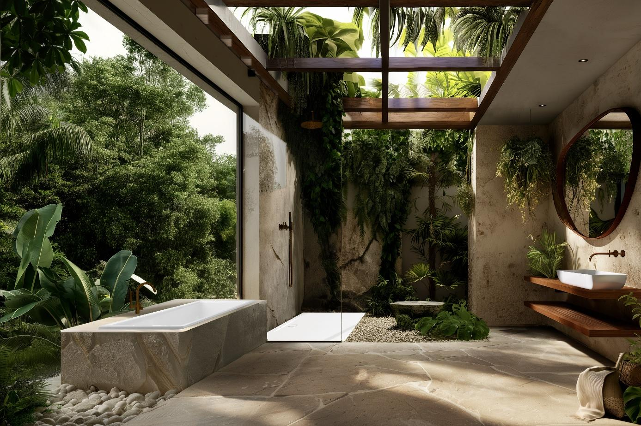
Photo: KALDEWEI
3_KALDEWEI_PURO_NEXT_with fittings_Alpine white_matt
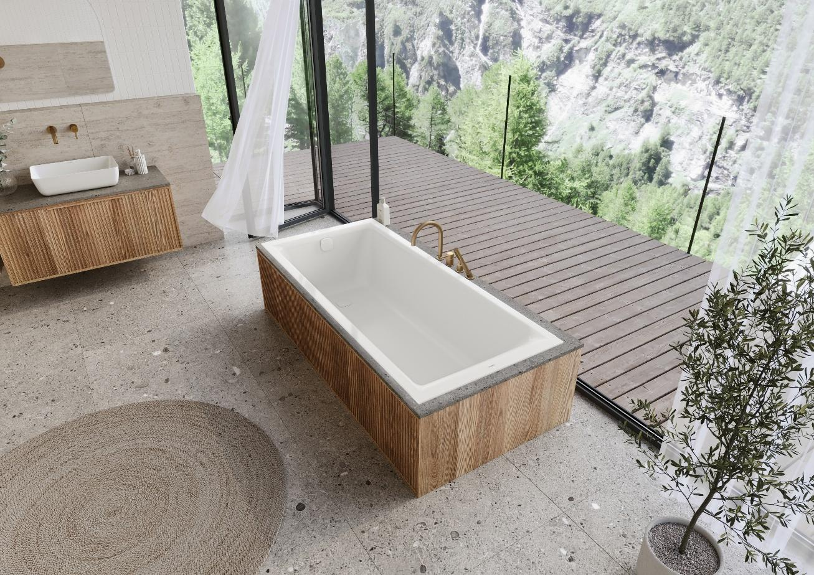
Photo: KALDEWEI
About KALDEWEI
When it comes to the bathroom, many people immediately think of KALDEWEI - and for good reason: The premium brand stands for excellent solutions for the personal dream bathroom as well as for recyclable materials and products. Around 600 of them carry the Cradle to Cradle® Certified certificate and underline the company’s consistently sustainable orientation. KALDEWEI is one of the first German bathroom manufacturers with the Cradle to Cradle® Certified certification by an independent body. Bathtubs, washbasins, shower solutions – all KALDEWEI products made of steel and glass are plastic-free and promise individual sensual luxury. This is defined by sophisticated aesthetics, responsible longevity and lasting joy in use. And this can be even increased: exclusive spa facilities pamper all the senses and transform the bathroom into a true experience space. Under the term LUXSTAINABILITY® Kaldewei combines innovative design that evokes a special attitude to life and a deeply rooted sustainability that characterises all KALDEWEI products. The LUXSTAINABILITY® philosophy of the company enables individual luxury for the senses and for every budget – for the first-class top hotels as well as for comfortable private bathrooms.
Press contacts:

Franz Kaldewei GmbH & Co. KG Tel. +49 (0) 2382 785 165
Georgina Trimbusch georgina.trimbusch@kaldewei.de
PO Box 1761 www.kaldewei.com
59206 Ahlen, Germany

Claudia Wünsch Communication GmbH Tel: +49 30 78956825
Massimiliano Monteverdi mm@claudia-wuensch.com
Mehringdamm 70 www.claudia-wuensch.com
10961 Berlin

UK press contact:

Esprit Media Ltd. Tel. +44 1428 788 098
Karen Brooks karen@espritpr.com
Stephanie Edwards-Morgan stephanie@espritpr.com
The old Chicken Shed
Kiln Cottage, Kiln Way
Grayshott
Hampshire, England

Further information and illustrations are available from Kaldewei’s virtual press office: www.kaldewei.com

