The Casa Rossa of the European Capital of Culture 2025:
A Contribution to Sustainable Building Culture
Impressive Bathroom Design with Kaldewei Bathtubs

KALDEWEI, Ahlen, May 2025 – For almost three decades, the Casa Rossa in Chemnitz’s Sonnenberg district stood vacant. Yet the plan to restore it as a residential building was never abandoned. From 2018 to 2020, Annette Fest and Christian Bodensteiner of bodensteiner fest architects carried out a careful renovation of the existing structure. For the bathroom design, the Munich-based architects chose the Classic Duo Oval bathtub from Kaldewei’s sustainability-oriented Luxstainability® world. Fittingly, a book has now been published to coincide with Chemnitz’s title as European Capital of Culture, documenting how sensitive restoration can be successful by means of a respectful approach to existing structures.

For Annette Fest and Christian Bodensteiner, sustainable approaches and a design that is both modern and high quality were key priorities in the project. The Classic Duo Oval bathtub from Kaldewei was a perfect match for the experienced architects, not only because it is a fully circular product, but also because it lends bathrooms a refined, elegant appearance. The idea of “democratic luxury” – combining meaningful, alluring design with suitable products that continue to delight users for years to come – fits perfectly with the overall concept. The architects were particularly interested in how simple means could be used to preserve or reuse as much of the existing structure as possible, highlighting its characteristics while still transforming the building for contemporary use. Saving grey energy and reducing CO₂ emissions were just as important to the concept as preserving and enhancing the cultural and architectural value of the structure.

As part of the ceiling replacement, the toilets that were once accessible from the stairwell landing were integrated into the respective apartments, and their ceilings were raised to match the level of the living spaces. In the new bathrooms, Kaldewei’s Classic Duo Oval bathtubs made of recyclable steel enamel feature prominently. Their purist design and timeless elegance give the bathrooms a clean, balanced aesthetic. With two identical backrests, the bathtubs even invite to shared bathing. Floor-to-ceiling windows provide a view from the tub into the maple tree canopy and the lush greenery of the courtyard, creating a relaxed, luxurious spa atmosphere in a nature-inspired setting. The bathroom design perfectly underscores the sustainability-focused renovation concept, which has already received several awards, including the Fritz Höger Award 2020 in Bronze and the Heinze Award 2020.
The recently published book about Casa Rossa Chemnitz offers a detailed yet accessible perspective for professionals in the real estate and construction industries, as well as for anyone interested in building culture and new approaches to preserving existing structures. With reflections on the value of design quality, simple building in existing structures, and the circular economy, the publication helps to broaden the understanding and appreciation of building culture – fittingly in Chemnitz’s year as European Capital of Culture 2025.

Information about the Book
Casa Rossa Chemnitz
A Contribution to Sustainable Building Culture
Edited by bodensteiner fest
With contributions by Deputy Mayor Michael Stötzer, Maria Meinel, David Kasparek,
Sabine Hausmann and Martin Neubert, Katharina Lichtner, Annette Fest
and Christian Bodensteiner, among others.
German / English, 228 pages, 248 photos, 32 plans
17 x 26 cm, Softcover, 2025
Deutscher Architektur Verlag
ISBN 978-3-946154-90-7

Images and captions:
0.1_Kaldewei_Casa_Rossa_Chemnitz_Straßenansicht
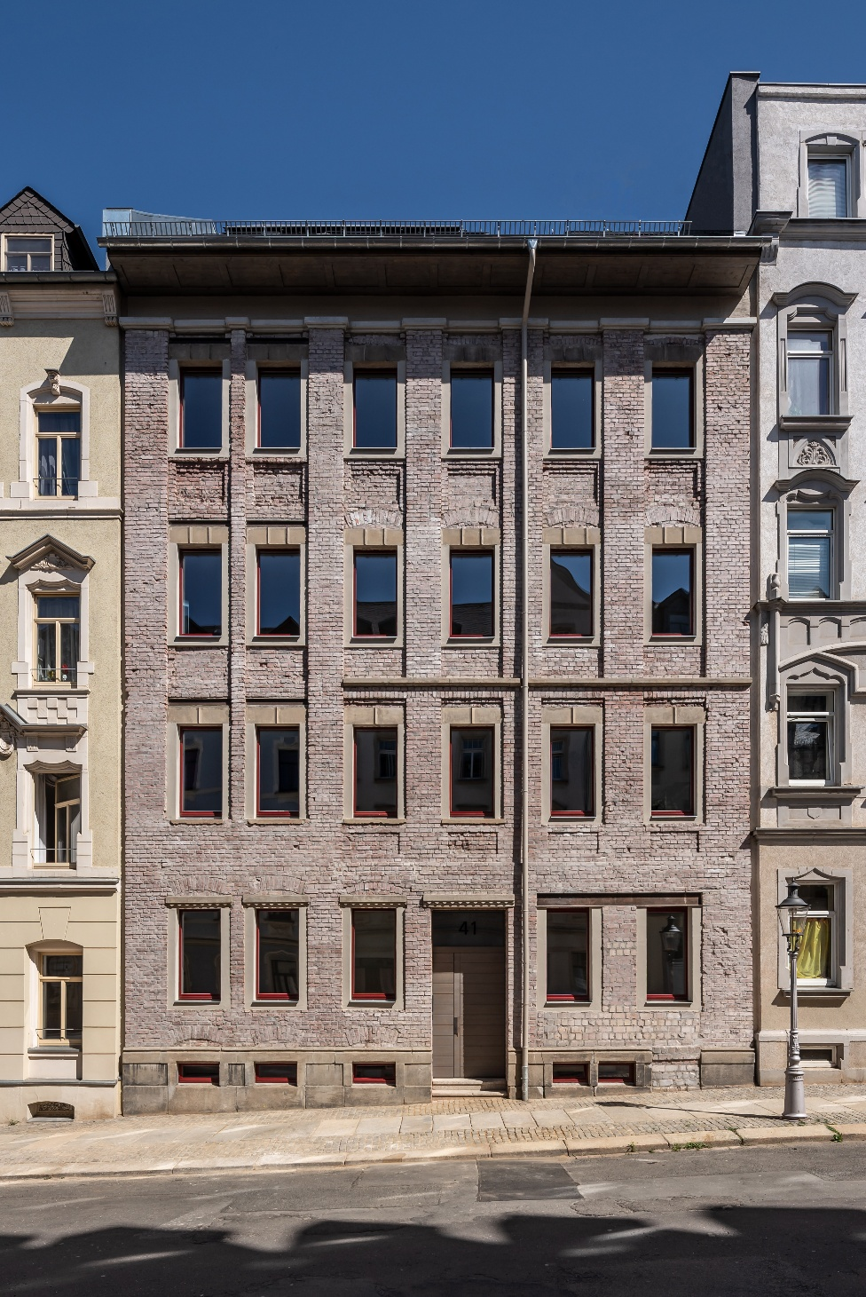
Foto: Sfeffen Spitzner
The renovated Casa Rossa sets a benchmark for sustainable preservation within the urban landscape of Chemnitz.

0.2_Kaldewei_Casa_Rossa_Chemnitz_Brickloft
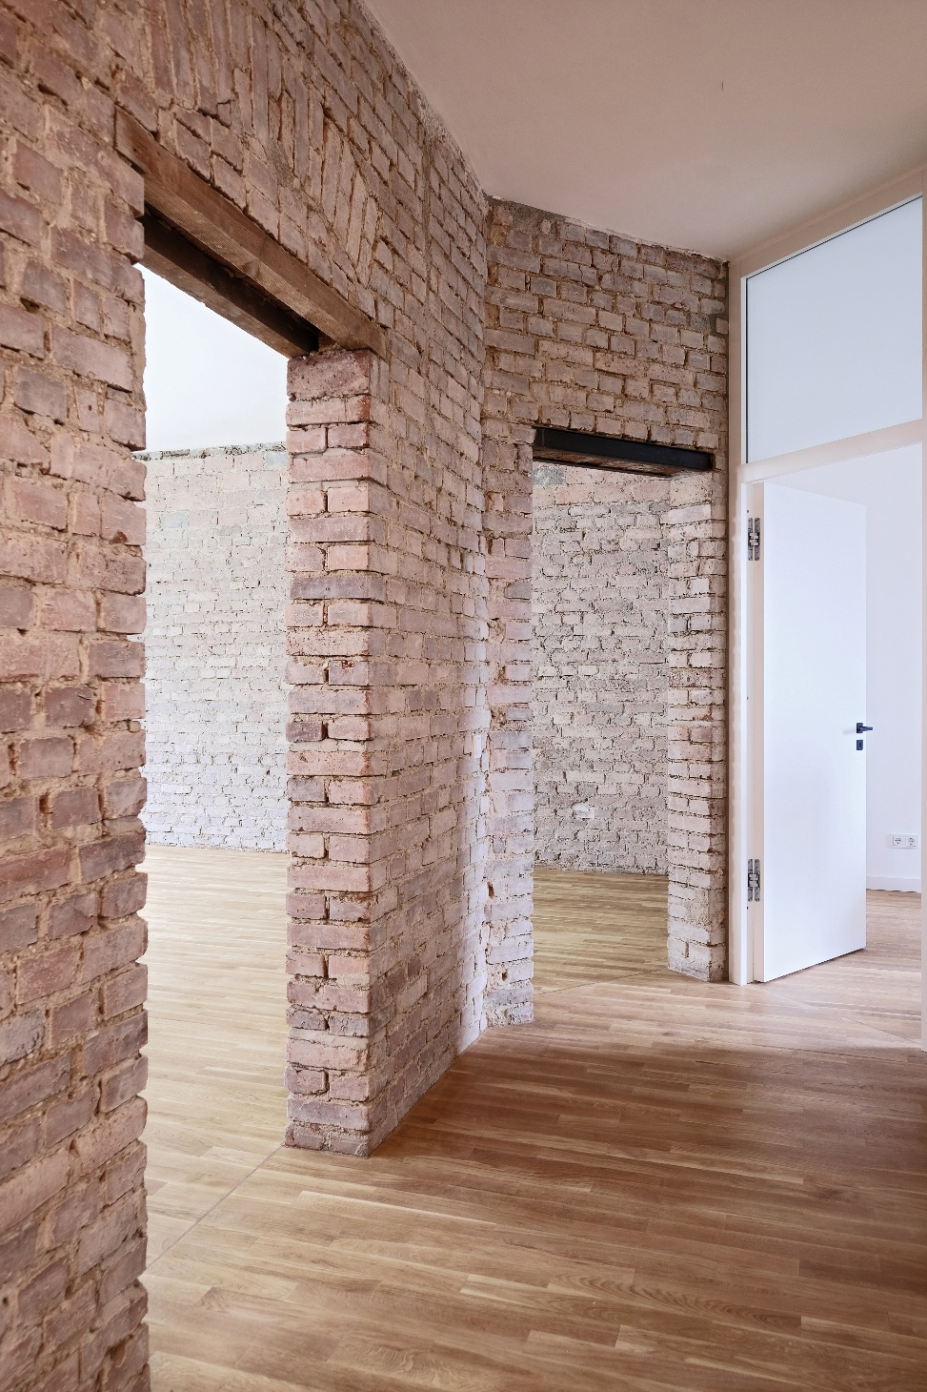
Foto: bodensteiner fest
The architects preserved the structure of the building, emphasized its characteristics, and adapted the building to modern requirements.
0.3_Kaldewei_Casa_Rossa_Chemnitz_Wohnungseingang
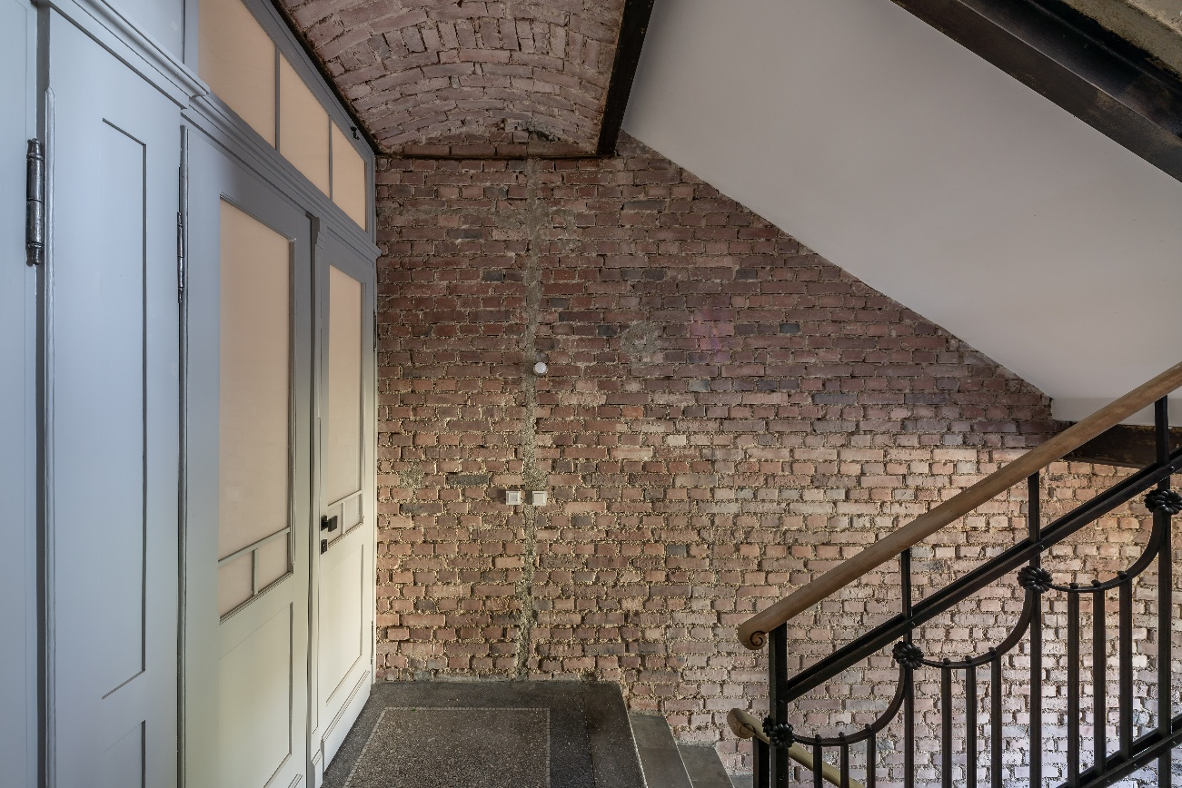
Foto: Sfeffen Spitzner
The entrance to the Casa Rossa exemplifies a respectful approach to the Gründerzeit-era structure.
0.4_Kaldewei_Casa_Rossa_Chemnitz_Maisonette
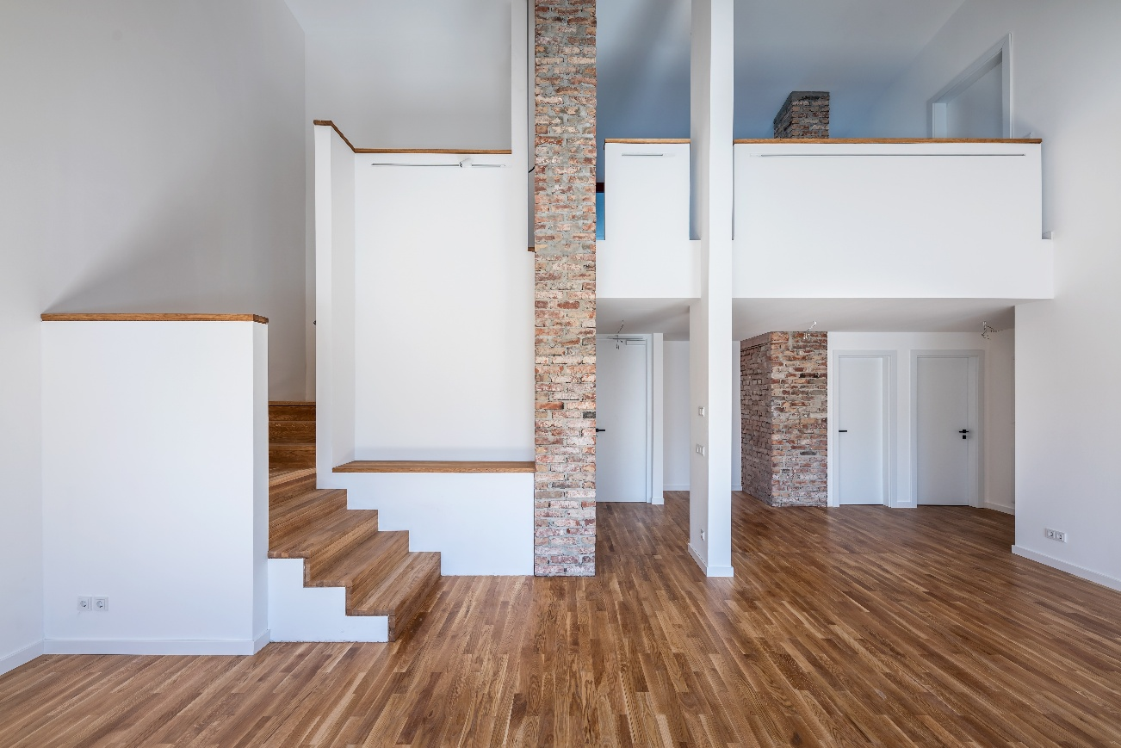
Foto: Sfeffen Spitzner
The duplex apartment reflects the central goal of the project – to preserve the existing structure, highlight its characteristics, and design it in a contemporary way.

0.5_Kaldewei_Casa_Rossa_Chemnitz_Brickloft
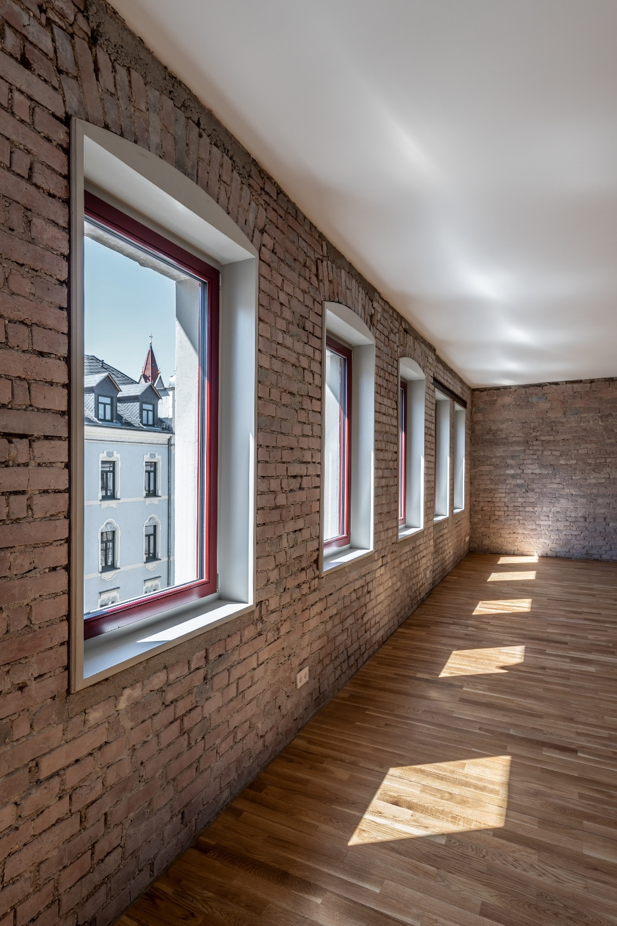
Foto: Sfeffen Spitzner
Light-filled rooms in the Brickloft open up views to the outside and skillfully combine the charm of the old building with contemporary design.

0.6_Kaldewei_Casa_Rossa_Chemnitz_Wannenbad_Classic_Duo_Oval
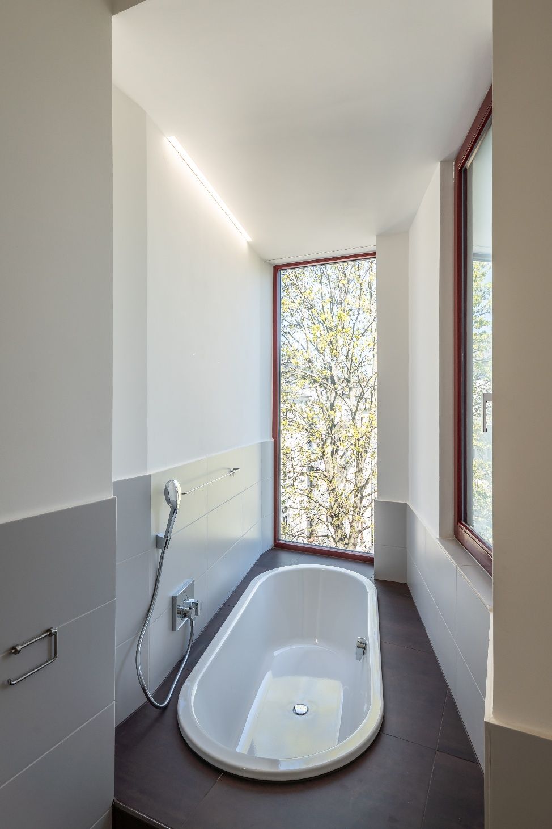
Foto: Sfeffen Spitzner
The new bathrooms feature the Classic Duo Oval bathtubs by Kaldewei, made from recyclable steel enamel, adding stylish and sustainable accents.
0.7_Kaldewei_Casa_Rossa_Chemnitz_Ahornblick
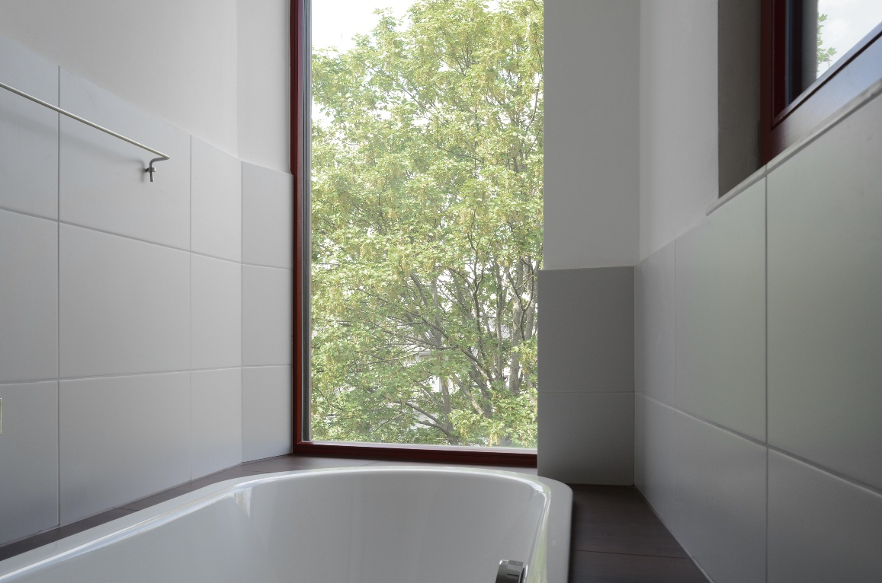
Foto: bodensteiner fest
Floor-to-ceiling windows offer a view of the greenery while bathing – creating a spa-like atmosphere right in the heart of the city.
0.8_Kaldewei_Casa_Rossa_Chemnitz_Wannenbad
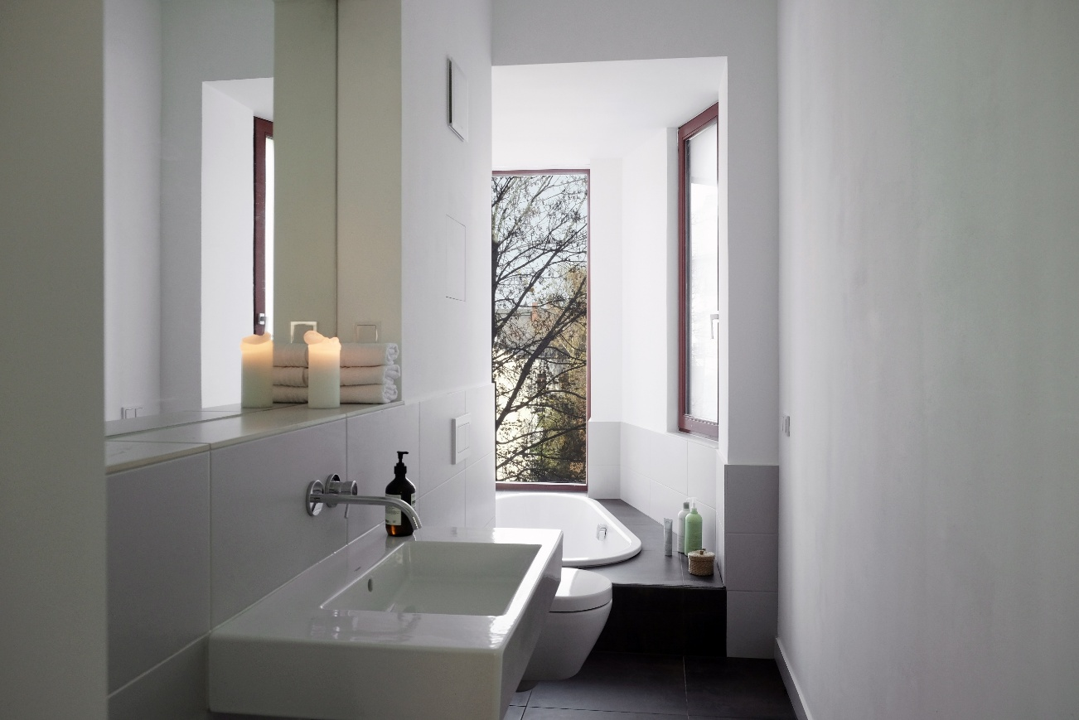
Foto: Leonie Fest
The Classic Duo Oval by Kaldewei integrates harmoniously into the modern bathroom concept, combining elegant design with sustainable material quality.
0.9_Kaldewei_Casa_Rossa_Chemnitz_Flur
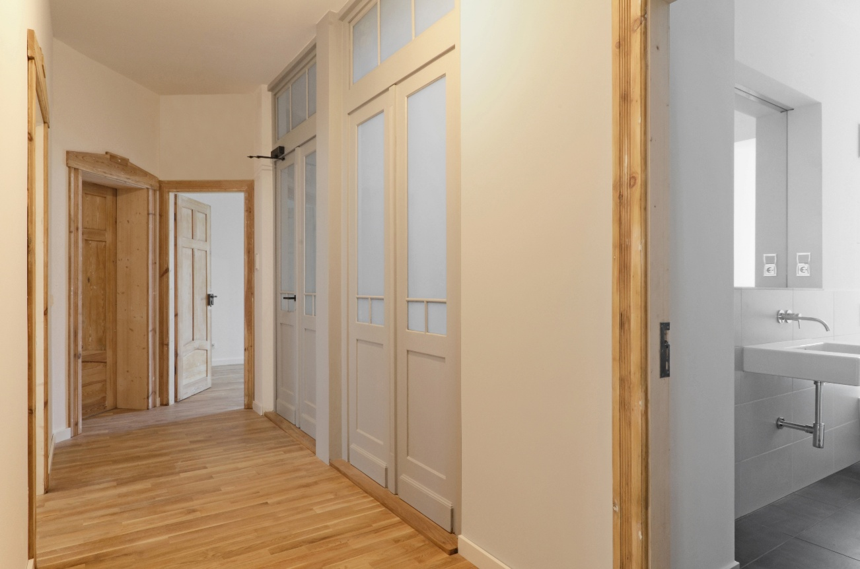
Foto: bodensteiner fest
The renovated hallway connects historical elements with contemporary design.
10_Kaldewei_Casa_Rossa_Chemnitz_Bestandstüren
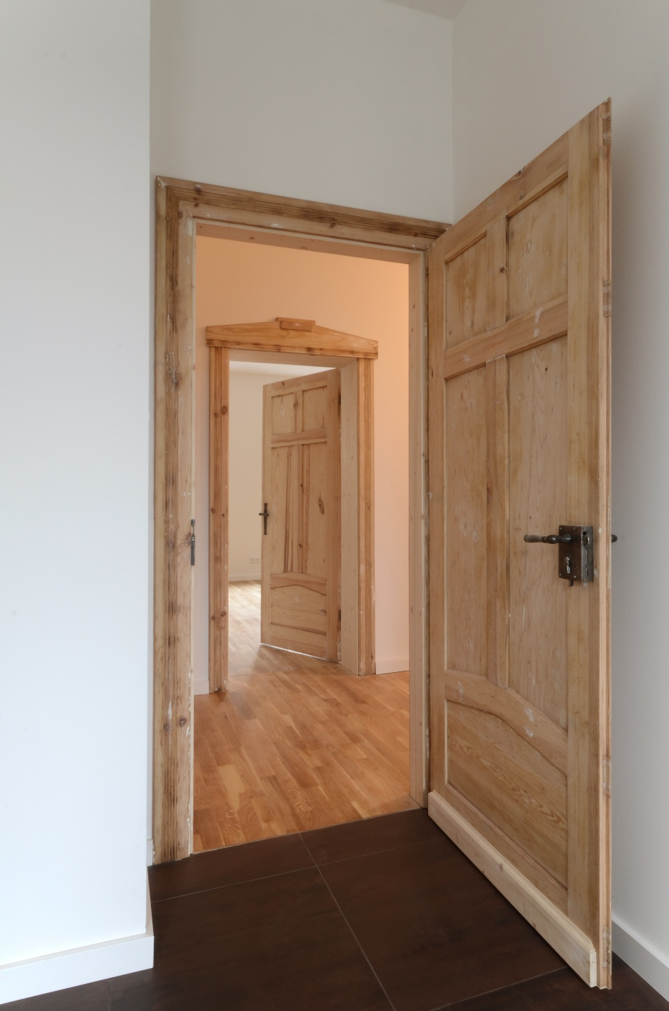
Foto: bodensteiner fest
Details with character: The preserved original doors of the building were reinstalled in one of the apartments, contributing to the authentic charm of the Casa Rossa.
11_Kaldewei_Casa_Rossa_Chemnitz_Maisonette_Dachterrasse
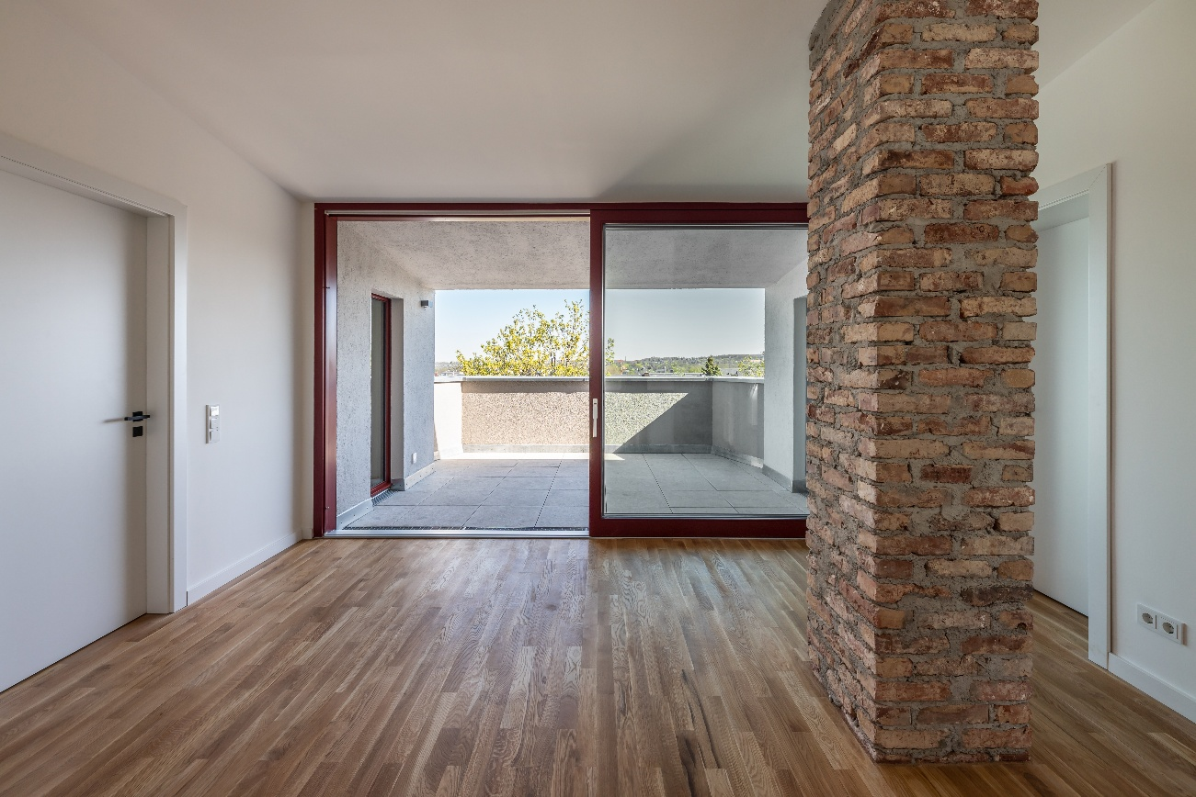
Foto: Sfeffen Spitzner
The rooftop terrace of the duplex creates a private retreat and extends the living space outdoors – right in the heart of the city.
12_Kaldewei_Casa_Rossa_Chemnitz_Ziegelrecycling
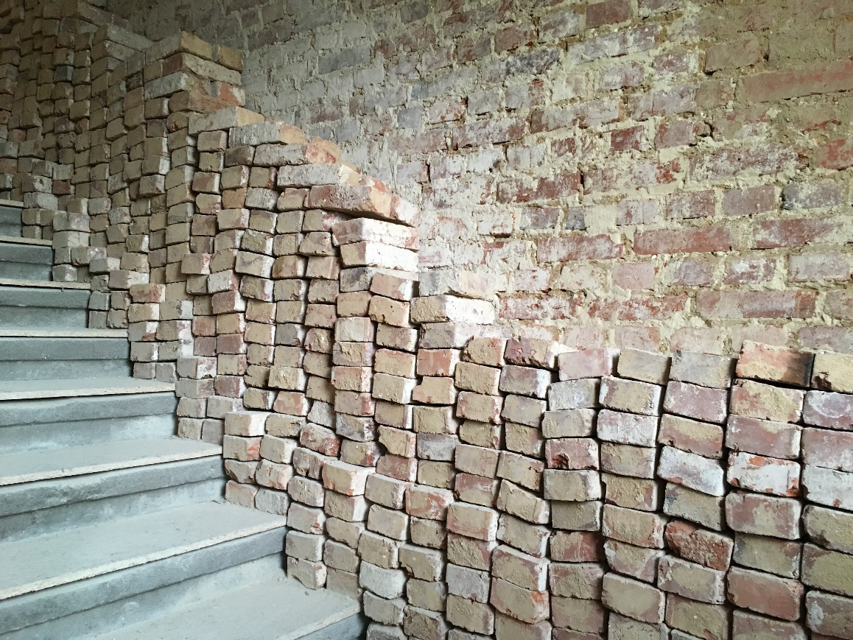
Foto: bodensteiner fest
Resource instead of waste: Through consistent brick recycling, valuable building materials were preserved, and grey energy was saved – a visible sign of sustainable renovation.
About KALDEWEI
When it comes to bathrooms, many people immediately think of KALDEWEI – and for good reason: The premium brand stands for excellent solutions for the personal dream bathroom, as well as for recyclable materials and products. Around 600 of these products carry the Cradle to Cradle® certification, underscoring the company's consistent commitment to sustainability. KALDEWEI is one of the first German bathroom manufacturers to receive the Cradle to Cradle® certification from an independent body. Bathtubs, washbasins, shower solutions – all KALDEWEI products made of steel and glass are plastic-free and promise a sense of luxurious individuality. This is defined by elegant aesthetics, responsible durability, and sustainable enjoyment of use. And this enjoyment can be even further enhanced: exclusive spa features indulge all the senses, transforming the bathroom into a true experience space. Under the term LUXSTAINABILITY®, KALDEWEI combines innovative design that creates a special lifestyle with a deeply rooted sustainability that characterizes all KALDEWEI products. The company’s LUXSTAINABILITY® philosophy enables individual luxury for the senses and for every budget – from top-tier hotels to comfortable private bathrooms.

Presscontact:

Franz Kaldewei GmbH & Co. KG Tel. +49 2382 785 165
Georgina Trimbusch georgina.trimbusch@kaldewei.de
Postfach 17 61 www.kaldewei.com
59206 Ahlen, Deutschland

Claudia Wünsch Communication GmbH Tel: +49 30 78956825
Massimiliano Monteverdi mm@claudia-wuensch.com
Silbersteinstraße 45 www.claudia-wuensch.com
12051 Berlin

UK press contact:
Esprit Media Ltd. Tel. +44 1428 788 098
Karen Brooks karen@espritpr.com
The old Chicken Shed
Kiln Cottage, Kiln Way
Grayshott
Hampshire, England

For more information and images, please visit the Kaldewei Press Center at:
www.kaldewei.co.uk/press

