Showering above the rooftops of Paris –
with a Superplan in a Chambre de Bonne

KALDEWEI, Ahlen, May 2025 – Living space has always been scarce and expensive in the city of love. For years, there has been a huge run on the so-called “Chambre de Bonne” in Paris - former attic rooms that were occupied by the staff of aristocrats, business people and major industrialists until the 20th century. Architect Massimo De Conti has now transformed one such space with a living area of just 11 square metres near the centrally located Gare du Nord into a compact mini-apartment. At the centre of his design is a shower capsule with a Superplan shower surface from Kaldewei.

Not much is needed in this Parisian micro-apartment on the sixth floor of a Haussmann-era building – a String Shelving desk, a Bensen daybed and a Vitra armchair are already enough. The apartment is primarily intended for short stays, business appointments or simply a weekend à la Seine. Architect Massimo De Conti has made a virtue of the lack of space here. The architect from Milan has been working for the London studio of Claudio Silvestrin for 25 years, whose philosophy of an elegant and never ostentatious style is in demand worldwide. His designs never fail to impress with their sensitivity, clarity and inventiveness – an approach that also suits Kaldewei perfectly.

The French name of these maid’s attic rooms is derived from the colloquial term “bonne à tout faire”, which could best be translated as “girl for everything”. People sleep or work on their laptops in the eleven square metres of the Chambre de Bonne in Paris. Every centimetre of the individual design was important. The entire interior was developed around the capsule with the customised Superplan. The shower surface from Kaldewei offers elegant aesthetics and a high level of comfort. Not least because of its low installation height, the Superplan is ideal for sanitary solutions in the Tiny Living sector, such as in this converted attic.

In addition to the bathroom area, the modernised Chambre de Bonne also has a small pantry and a mini-kitchen with a microwave, fridge and cooker, which can be pulled out when needed. The wooden screen originally planned for the shower capsule has also been given a metal finish, which provides noticeably more light throughout the room. Both natural and artificial light is moderately intensified by the subtly shimmering surface. The dominant white and metal surfaces are accentuated by three shades of blue chosen for the wall. The floor is a sophisticated midnight blue. Finally, the daybed, armchair and desk provide a harmonious, warm contrast with their brown tones.

Images:
0.1_Kaldewei_Chambre_de_Bonne_Paris
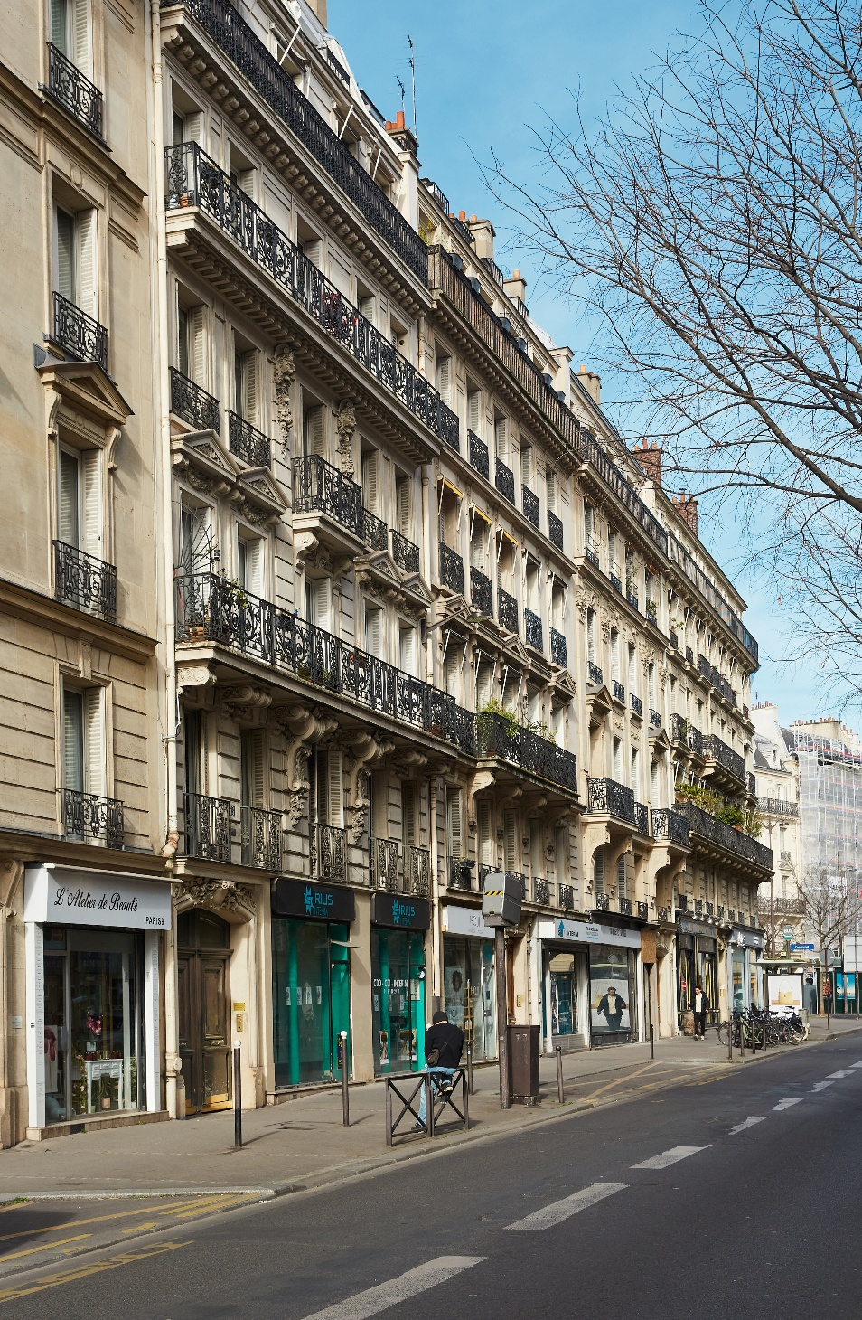
Photo: Marco Guastalla

0.2_Kaldewei_Chambre_de_Bonne_Paris
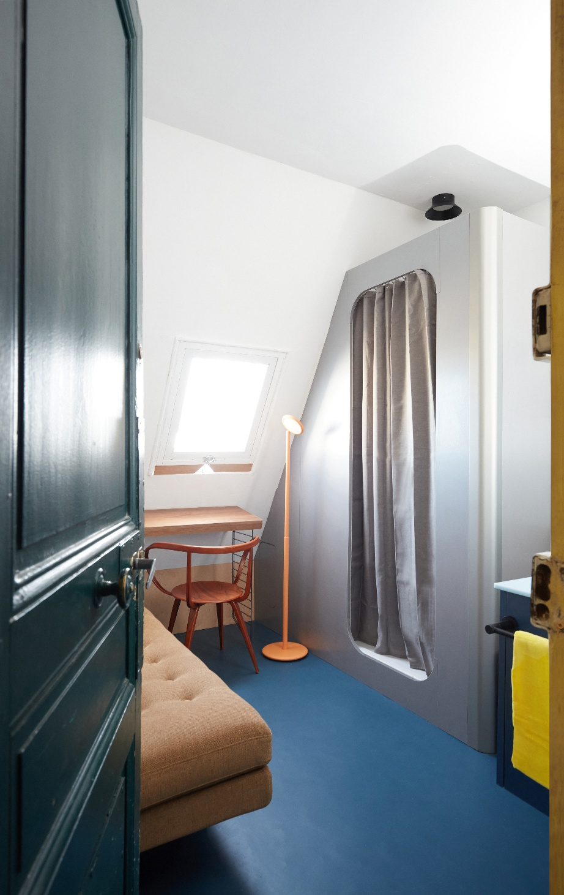
Photo: Marco Guastalla

0.3_Kaldewei_Chambre_de_Bonne_Paris
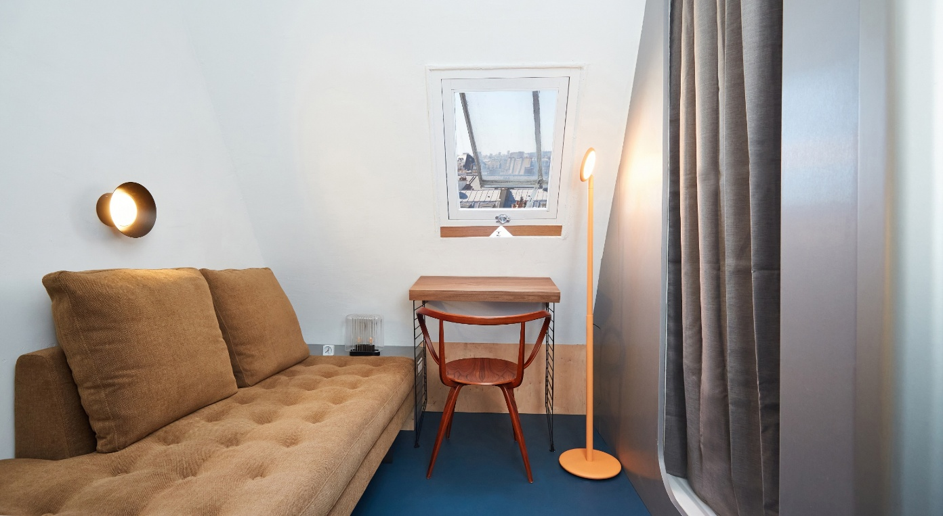
Photo: Marco Guastalla

0.4_Kaldewei_Chambre_de_Bonne_Paris
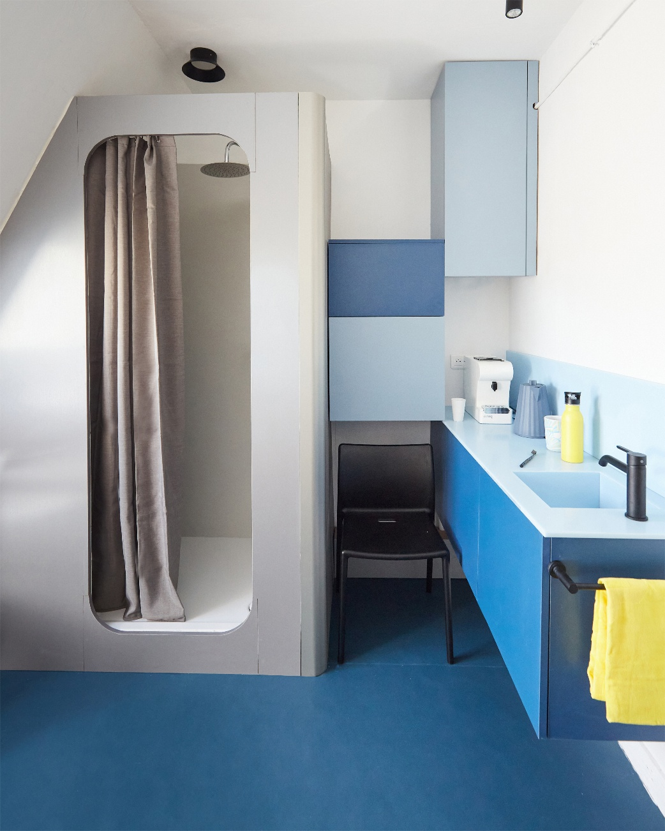
Photo: Marco Guastalla

0.5_Kaldewei_Chambre_de_Bonne_Paris_Superplan
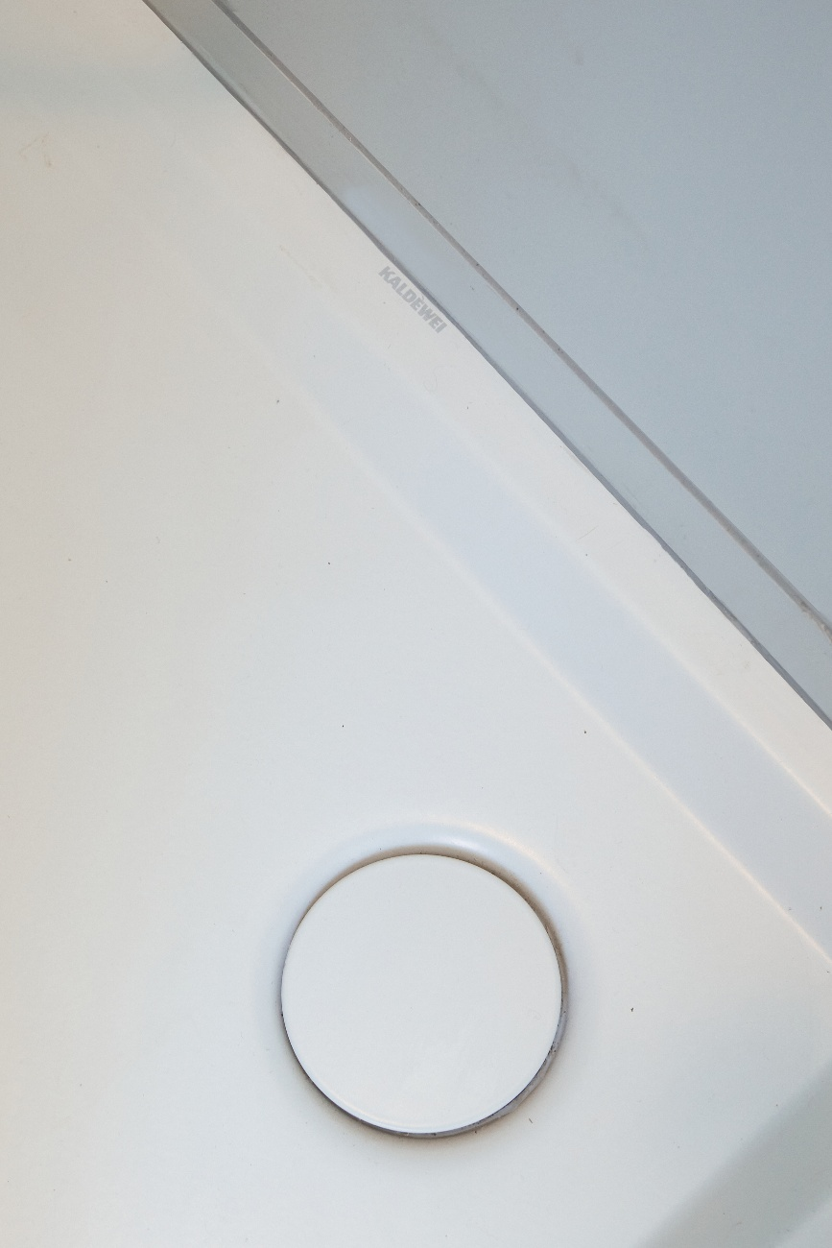
Photo: Marco Guastalla

0.6_Kaldewei_Chambre_de_Bonne_Paris
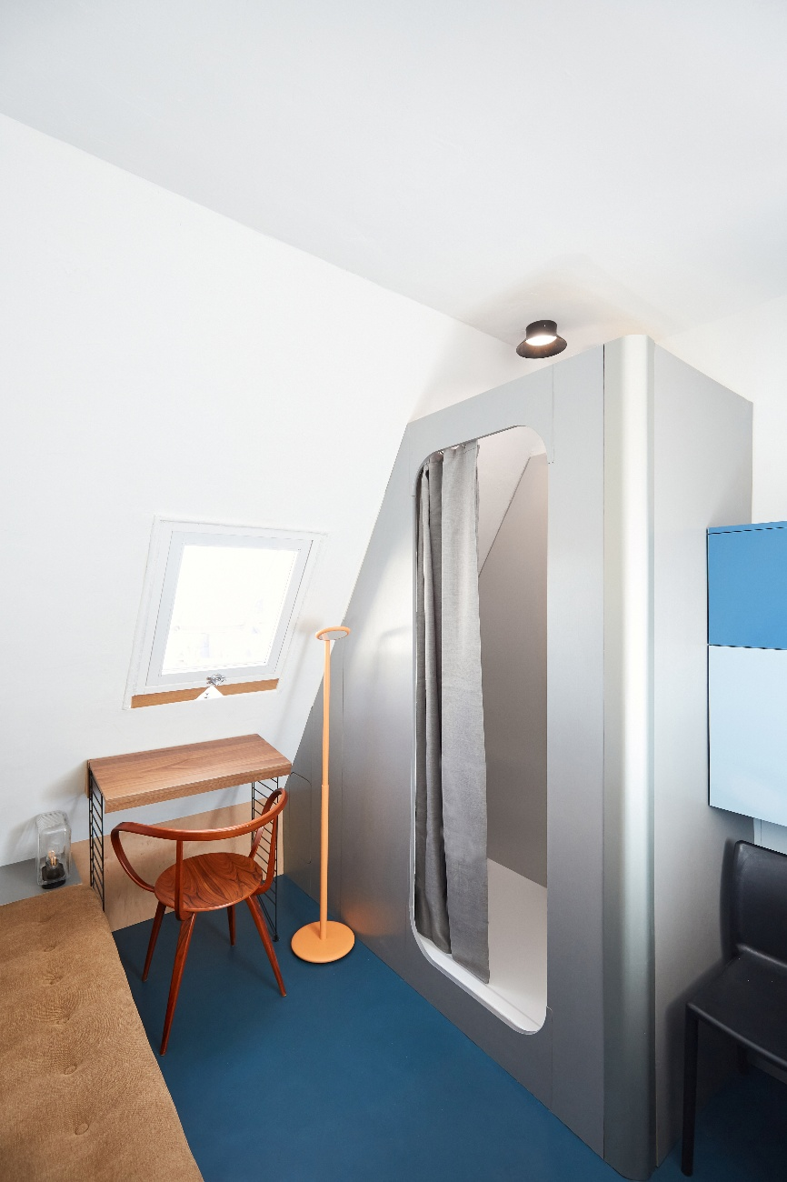
Photo: Marco Guastalla

0.7_Kaldewei_Chambre_de_Bonne_Paris
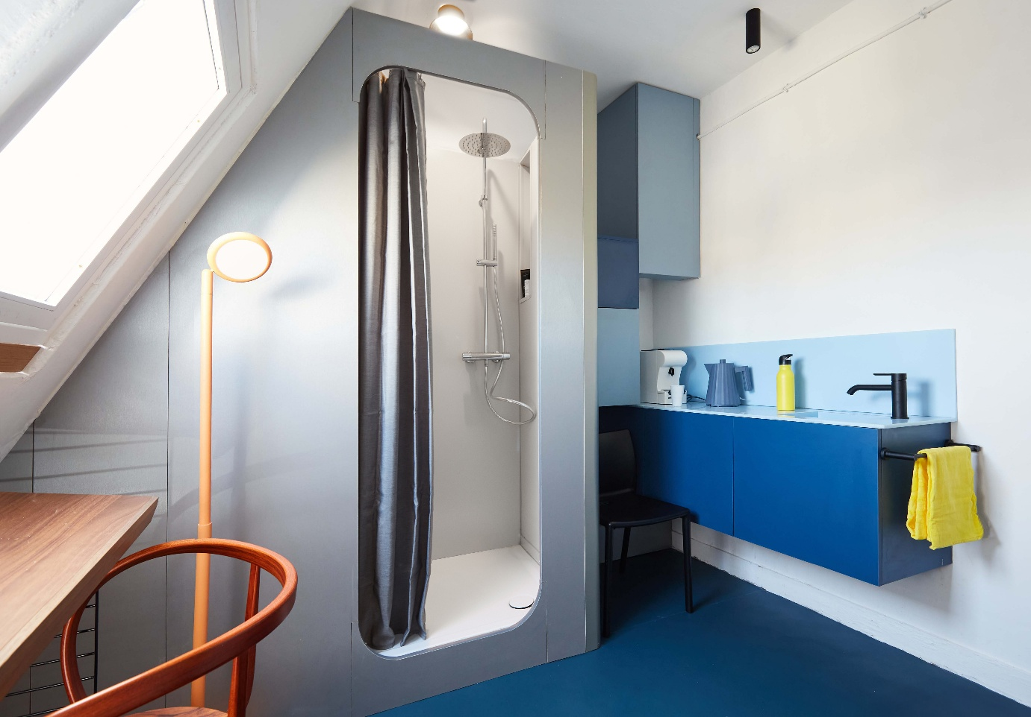
Photo: Marco Guastalla

About KALDEWEI
When it comes to the bathroom, many people immediately think of KALDEWEI - and for good reason: The premium brand stands for excellent solutions for the personal dream bathroom as well as for recyclable materials and products. Around 600 of them carry the Cradle to Cradle® Certified certificate and underline the company’s consistently sustainable orientation. KALDEWEI is one of the first German bathroom manufacturers with the Cradle to Cradle® Certified certification by an independent body. Bathtubs, washbasins, shower solutions – all KALDEWEI products made of steel and glass are plastic-free and promise individual sensual luxury. This is defined by sophisticated aesthetics, responsible longevity and lasting joy in use. And this can be even increased: exclusive spa facilities pamper all the senses and transform the bathroom into a true experience space. Under the term LUXSTAINABILITY® Kaldewei combines innovative design that evokes a special attitude to life and a deeply rooted sustainability that characterises all KALDEWEI products. The LUXSTAINABILITY® philosophy of the company enables individual luxury for the senses and for every budget – for the first-class top hotels as well as for comfortable private bathrooms.

Press contacts:

Franz Kaldewei GmbH & Co. KG Tel. +49 2382 785 165
Georgina Trimbusch georgina.trimbusch@kaldewei.de
PO Box 1761 www.kaldewei.com
59206 Ahlen, Germany

Claudia Wünsch Communication GmbH Tel: +49 30 78956825
Massimiliano Monteverdi mm@claudia-wuensch.com
Silbersteinstraße 45 www.claudia-wuensch.com
12051 Berlin

UK press contact:

Esprit Media Ltd. Tel. +44 1428 788 098
Karen Brooks karen@espritpr.com
The old Chicken Shed
Kiln Cottage, Kiln Way
Grayshott
Hampshire, England

Further information and illustrations are available from Kaldewei’s virtual press office: www.kaldewei.com

