The Show(er) must go on: Invisible Grip in new colour shades
Kaldewei ensures perfect poise in your individual dream bathroom

KALDEWEI, Ahlen, March 2025 – One thing is for sure: the increased stability of the invisible surface finish Invisible Grip from Kaldewei. Invisible Grip is the perfect solution for anyone who wants carefree safety in the shower, but does not want to forego an elegant bathroom design.
Safe standing in any colour
Now safe standing in the bathroom has taken on a whole new look. Kaldewei is now offering the revolution in surface design in all colours of the Coordinated Colours Collection: from warm beige or grey tones to cool grey nuances and elegant black with a matt look.
The latest Kaldewei surface treatment for showers, Invisible Grip, only unfolds its full power when used with water. When stepping on the wet surface, an invisible micro-structure ensures particularly strong grip and optimises barefoot standing safety – even with soap foam or shampoo. At the same time, Invisible Grip offers an impeccable look and feel, and nothing stands in the way of lightning-fast cleaning of the elegant bathroom objects.
Safely in style
Shower surfaces can now also be integrated into well thought-out design concepts and harmonious colour compositions with increased safety. This is how bathroom dreams can become reality – with maximum comfort and aesthetics.

Images and captions:

6.1_Kaldewei_InvisibleGrip_CCC
Photo: KALDEWEI

Kaldewei is now offering the revolution in surface design in all colours of the Coordinated Colours Collection: from warm beige or grey tones to cool grey nuances and elegant black with a matt look.

6.2_Kaldewei_InvisibleGrip
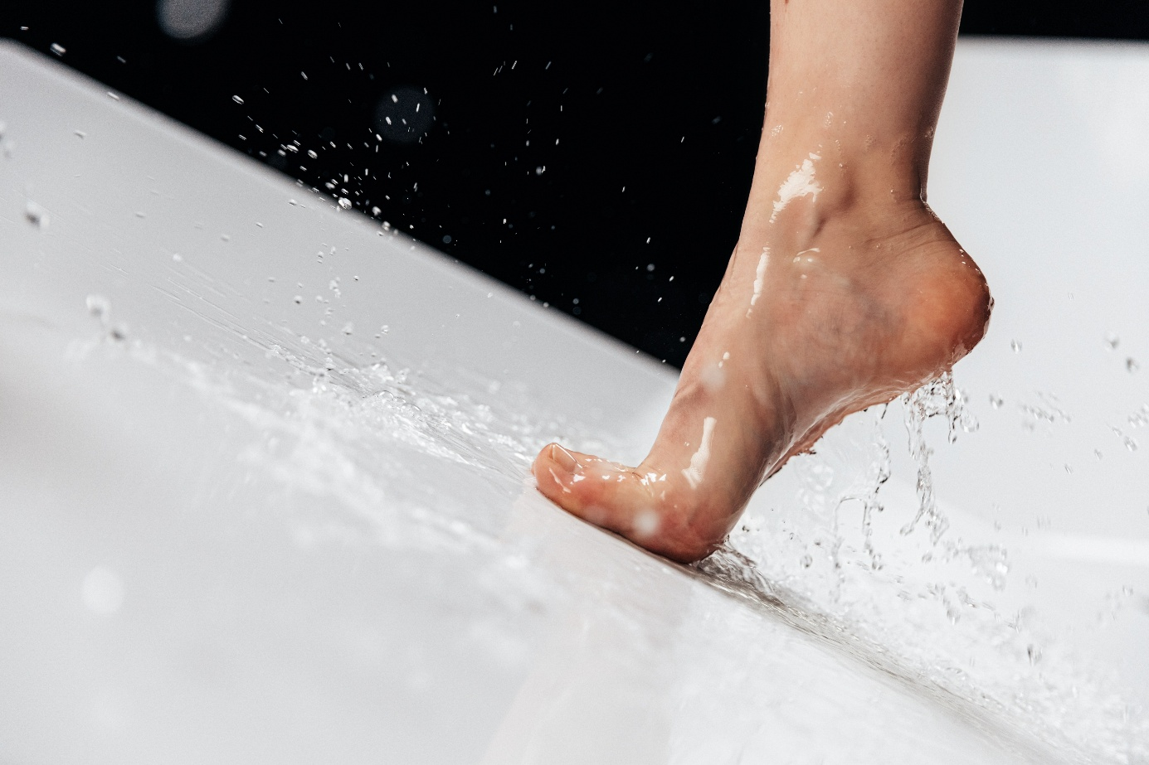
Photo: KALDEWEI

When stepping on the wet surface, an invisible micro-structure ensures particularly strong grip and optimises barefoot standing safety.

About KALDEWEI
When it comes to the bathroom, many people immediately think of KALDEWEI - and for good reason: The premium brand stands for excellent solutions for the personal dream bathroom as well as for recyclable materials and products. Around 600 of them carry the Cradle to Cradle® Certified certificate and underline the company’s consistently sustainable orientation. KALDEWEI is one of the first German bathroom manufacturers with the Cradle to Cradle® Certified certification by an independent body. Bathtubs, washbasins, shower solutions – all KALDEWEI products made of steel and glass are plastic-free and promise individual sensual luxury. This is defined by sophisticated aesthetics, responsible longevity and lasting joy in use. And this can be even increased: exclusive spa facilities pamper all the senses and transform the bathroom into a true experience space. Under the term LUXSTAINABILITY® Kaldewei combines innovative design that evokes a special attitude to life and a deeply rooted sustainability that characterises all KALDEWEI products. The LUXSTAINABILITY® philosophy of the company enables individual luxury for the senses and for every budget – for the first-class top hotels as well as for comfortable private bathrooms.

Press contacts:

Franz Kaldewei GmbH & Co. KG Tel. +49 2382 785 209
Marcus Möllers Fax +49 2382 785 8209
PO Box 1761 marcus.moellers@kaldewei.de
59206 Ahlen, Germany www.kaldewei.com

Claudia Wünsch Communication GmbH Tel: +49 30 78956825
Massimiliano Monteverdi Fax:+49 30 69531380
Silbersteinstraße 45 mm@claudia-wuensch.com
12051 Berlin www.claudia-wuensch.com

UK press contact:

Esprit Media Ltd. Tel. +44 1428 788 098
Karen Brooks karen@espritpr.com
Stephanie Edwards-Morgan stephanie@espritpr.com
The old Chicken Shed
Kiln Cottage, Kiln Way
Grayshott
Hampshire, England

Further information and illustrations are available from Kaldewei’s virtual press office: www.kaldewei.com

