Kaldewei FlowPoint Zero: Elegance and functionality at the highest level
New point waste expands the portfolio of designer shower wastes

KALDEWEI, Ahlen, March 2025 – At the ISH in Frankfurt, Kaldewei is expanding its portfolio of designer shower wastes with the FlowPoint Zero. Following the successful launch of the FlowLine Zero shower profile, it quickly became very popular with market partners and end consumers. A targeted expansion of the shower waste segment is therefore only logical and fulfils the wishes of Kaldewei customers.

The elegant new product combines sophisticated aesthetics with technical perfection and represents a new generation of floor-level and barrier-free shower areas. Designed by the renowned designer Werner Aisslinger, the waste impresses with its high-quality workmanship made of solid stainless steel. The panel blends seamlessly into any bathroom ambience and is available in five stylish designs. Brushed surfaces in stainless steel, champagne and graphite as well as black matt and alpine white matt can be chosen. With its low installation height and the ability to be positioned freely in the floor-level shower area, the FlowPoint Zero offers maximum flexibility in bathroom design.

K-Click' n Clean® mechanism inspires
Cleaning the FlowPoint Zero is well thought out and user-friendly. The innovative K-Click'n Clean® Mechanism allows effortless opening and closing with one hand, while the easily removable siphon simplifies cleaning. Emphasis is placed not only on functionality, but also on the everyday suitability of the product. This is appreciated by private users as well as those responsible for project business, for example in the hotel industry.

All-in-one set for quick installation
Installing the FlowPoint Zero is both simple and efficient. Two different FlowDrain waste fittings enable installation heights from 59 to 179 mm. The all-in-one set ensures quick installation, secure sealing and effective sound insulation.

Images and captions:

5.1_Kaldewei_FlowPoint

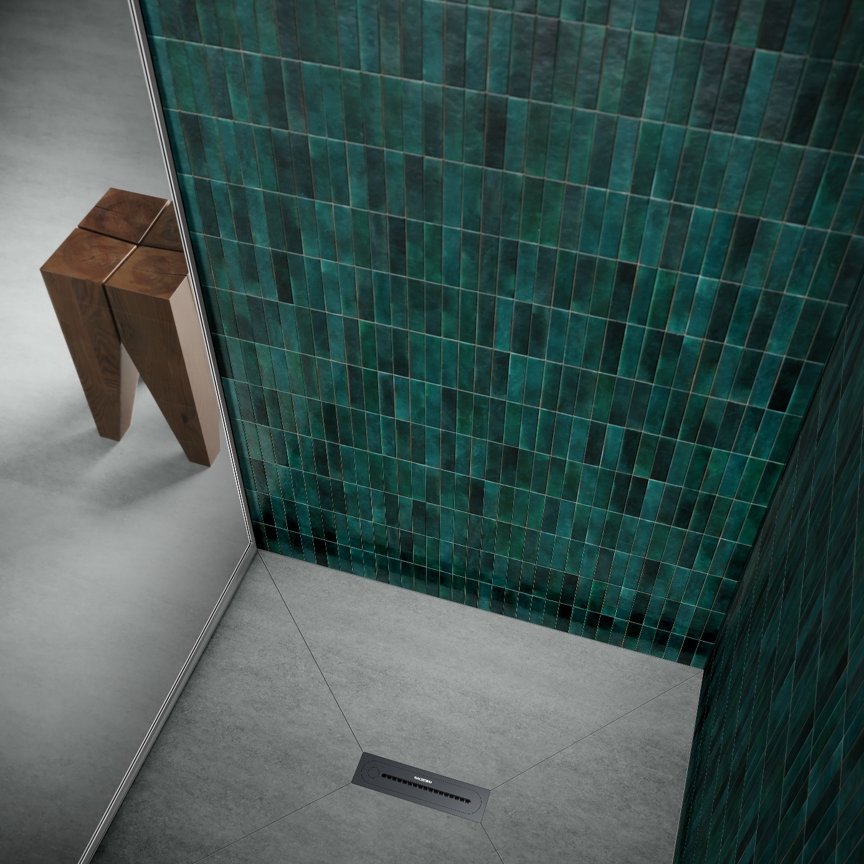
Photo: KALDEWEI

The elegant Kaldewei FlowPoint Zero combines elegant aesthetics with technical perfection and represents a new generation of floor-level and barrier-free shower areas.

5.2_Kaldewei_FlowPoint

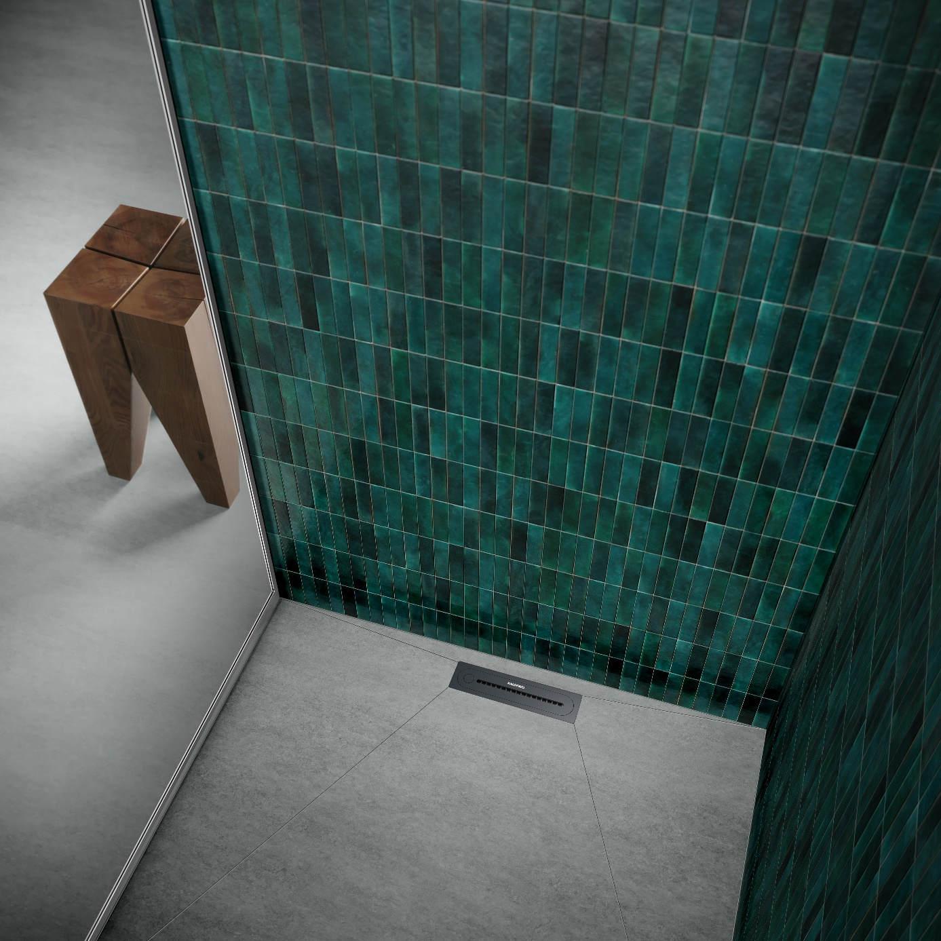
Photo: KALDEWEI

With its low installation height and the ability to be positioned freely in the floor-level shower area, FlowPoint Zero offers maximum flexibility in bathroom design.

5.3_Kaldewei_FlowPoint

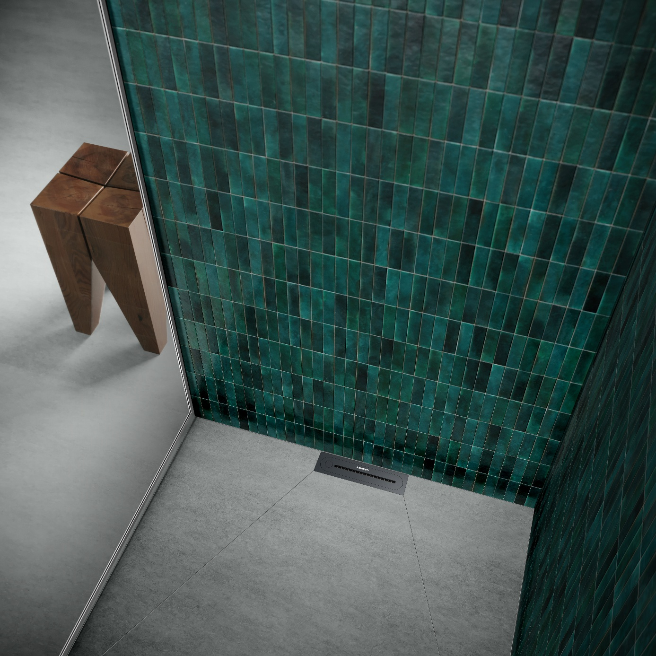
Photo: KALDEWEI

Designed by the renowned designer Werner Aisslinger, the waste impresses with its high-quality workmanship made of solid stainless steel – here in black matt.

5.4_Kaldewei_FlowPoint_Chp
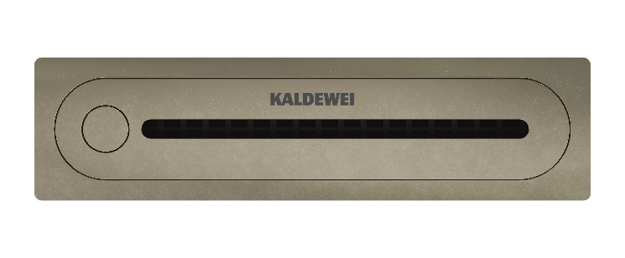
Photo: KALDEWEI

Kaldewei FlowPoint Zero in champagne

5.5_Kaldewei_FlowPoint_Es
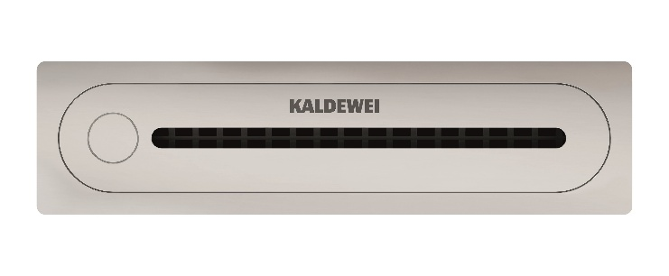
Photo: KALDEWEI

Kaldewei FlowPoint Zero in steel brushed

5.6_Kaldewei_FlowPoint_Gr
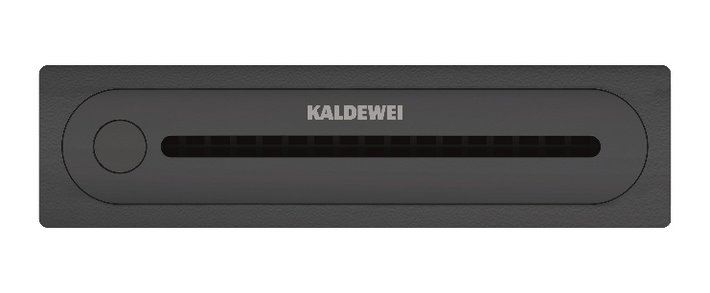
Photo: KALDEWEI

Kaldewei FlowPoint Zero graphite

5.7_Kaldewei_FlowPoint_B
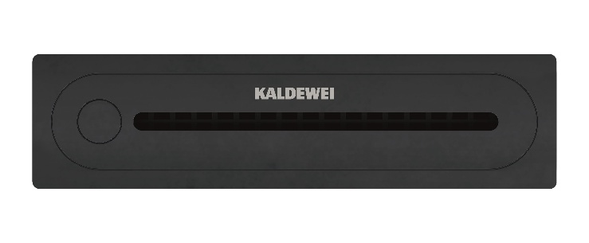
Photo: KALDEWEI

Kaldewei FlowPoint Zero black matt

5.8_Kaldewei_FlowPoint_W
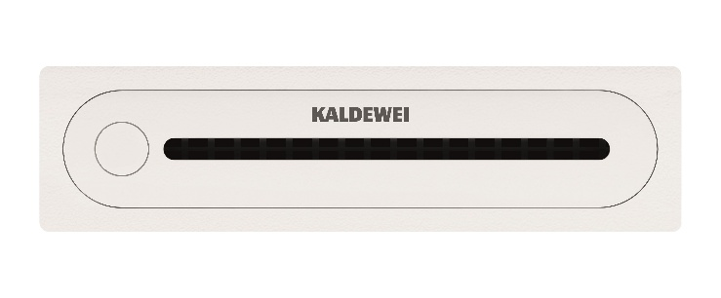
Photo: KALDEWEI

Kaldewei FlowPoint Zero white

About KALDEWEI
When it comes to the bathroom, many people immediately think of KALDEWEI - and for good reason: The premium brand stands for excellent solutions for the personal dream bathroom as well as for recyclable materials and products. Around 600 of them carry the Cradle to Cradle® Certified certificate and underline the company’s consistently sustainable orientation. KALDEWEI is one of the first German bathroom manufacturers with the Cradle to Cradle® Certified certification by an independent body. Bathtubs, washbasins, shower solutions – all KALDEWEI products made of steel and glass are plastic-free and promise individual sensual luxury. This is defined by sophisticated aesthetics, responsible longevity and lasting joy in use. And this can be even increased: exclusive spa facilities pamper all the senses and transform the bathroom into a true experience space. Under the term LUXSTAINABILITY® Kaldewei combines innovative design that evokes a special attitude to life and a deeply rooted sustainability that characterises all KALDEWEI products. The LUXSTAINABILITY® philosophy of the company enables individual luxury for the senses and for every budget – for the first-class top hotels as well as for comfortable private bathrooms.

Press contacts:

Franz Kaldewei GmbH & Co. KG Tel. +49 2382 785 209
Marcus Möllers Fax +49 2382 785 8209
PO Box 1761 marcus.moellers@kaldewei.de
59206 Ahlen, Germany www.kaldewei.com

Claudia Wünsch Communication GmbH Tel: +49 30 78956825
Massimiliano Monteverdi Fax:+49 30 69531380
Silbersteinstraße 45 mm@claudia-wuensch.com
12051 Berlin www.claudia-wuensch.com

UK press contact:

Esprit Media Ltd. Tel. +44 1428 788 098
Karen Brooks karen@espritpr.com
Stephanie Edwards-Morgan stephanie@espritpr.com
The old Chicken Shed
Kiln Cottage, Kiln Way
Grayshott
Hampshire, England

Further information and illustrations are available from Kaldewei’s virtual press office: www.kaldewei.com

