Bathe beautifully and comfortably: Kaldewei Puro Next
The modern facelift continues the success story of the popular bathtub series

KALDEWEI, Ahlen, March 2025 – With a facelift, the success story of the Puro bathtub series is entering its next phase. The Kaldewei Puro Next impresses with a modern appearance that is characterised by a particularly slender and attractive design. Comfort is paired with robust quality and an easy-care surface. The Kaldewei Puro Next democratises individual luxury for a broad target group: from young couples and families with children to best agers.
The Puro Next series offers three variants for different needs: The Kaldewei Puro Next single-seater bathtub offers individual bathing comfort thanks to a generous lying surface, the Kaldewei Puro Next Duo enables bathing for two thanks to two ergonomic backrests, and the Kaldewei Puro Next Combi combines relaxed bathing and refreshing showering in one product with a secure standing surface. With six sizes from 160 x 70 cm to 190 x 90 cm, the series covers a wide range of bathroom solutions for different floor plans and ensures flexibility in bathroom planning.

There are no compromises when it comes to the surface either: The tub made of glazed steel is impact and scratch resistant, does not discolour and remains permanently impeccable even under heavy use. This has already proven itself hundreds of thousands of times in busy hotel bathrooms and in private bathing oases.

Modern Design: Sleek and Safety
A special highlight of the Kaldewei Puro Next is its extra-flat tub edge with a height of only 10 mm, which impresses with its modern and elegant appearance and characterises the design of the Kaldewei bathtub. The low edge and precise radii enable seamless integration of the Kaldewei Puro Next into the tiled surface. A generous floor length and the ergonomic back slope with a softly tapered neck area also ensure a comfortable lying position, while the comfortable entry height and optionally available grips make it easier to use in every phase of life.

But that’s not all: The glazed surface creates an elegant appearance and allows the tub to shine again quickly and effortlessly after each bath. And on request, surface finishes such as Invisible Grip or Antislip provide additional slip resistance in the Kaldewei Puro Next bathtub.

With the facelift of the popular Puro family, Kaldewei has succeeded in raising this successful series to a modern level. The result is a bathtub that is characterised by its elegant, flat tub edge and meets the highest standards of comfort for all generations and ease of care.

Images and captions:

4.1_Kaldewei_PuroNextDuo_AWmatt
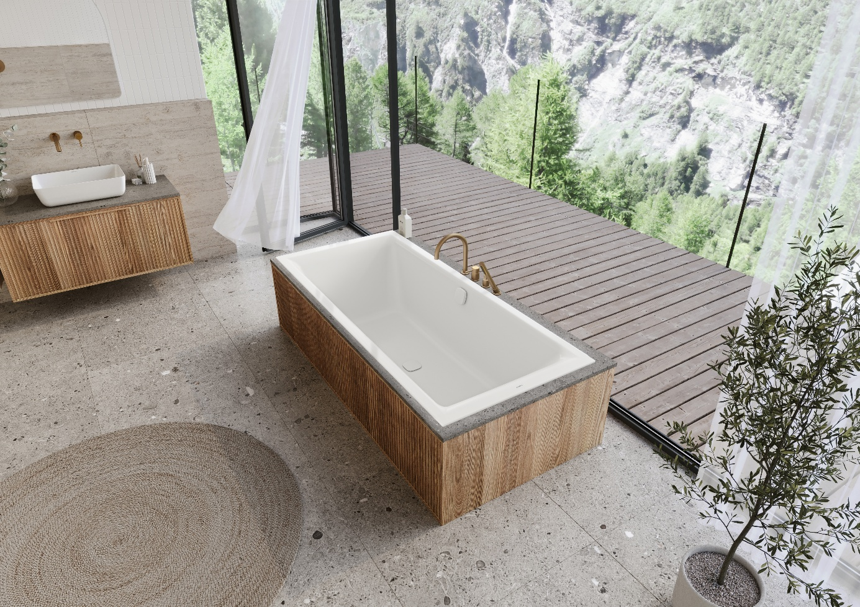
Photo: KALDEWEI

After a facelift, the popular Kaldewei Puro Next family democratises individual luxury for a broad target group: from young couples and families with children to best agers – here the Puro Next Duo in alpine white matt.

4.2_Kaldewei_PuroNextDuo_AW
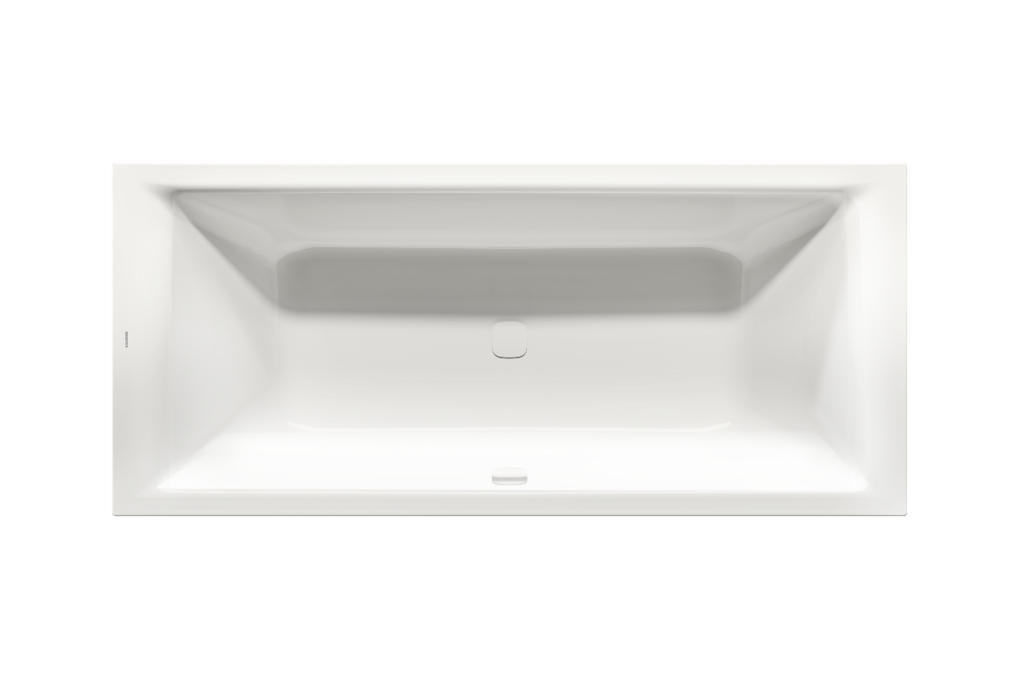
Photo: KALDEWEI

Kaldewei Puro Next Duo in alpine white: the Kaldewei Puro Next Duo allows bathing for two thanks to two ergonomic backrest slopes.

4.3_Kaldewei_PuroNextCombi_PM
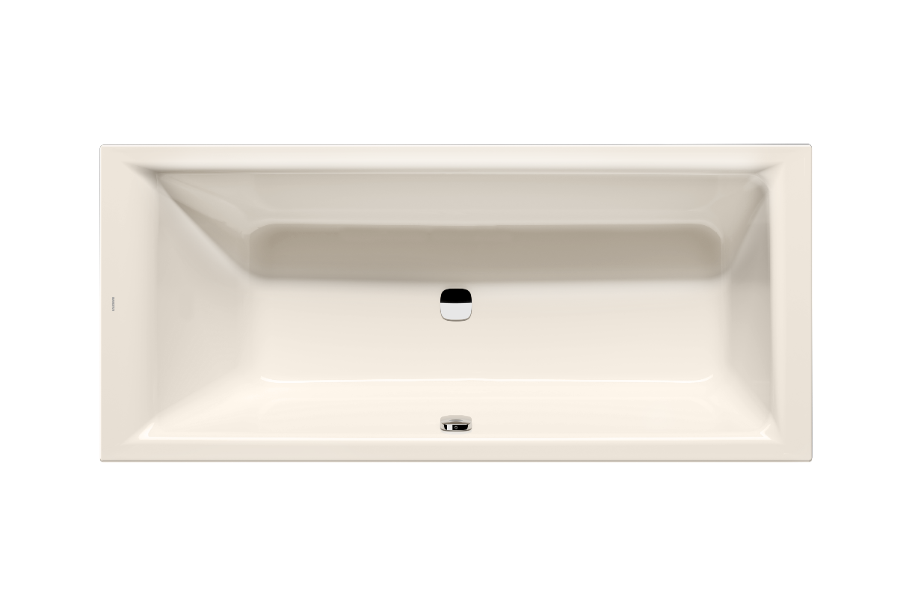
Photo: KALDEWEI

Kaldewei Puro Next Combi in the colour pergamon: thanks to a secure standing area, the Kaldewei Puro Next Combi combines relaxing bathing and refreshing showering in one product.

4.4_Kaldewei_PuroNext_MH
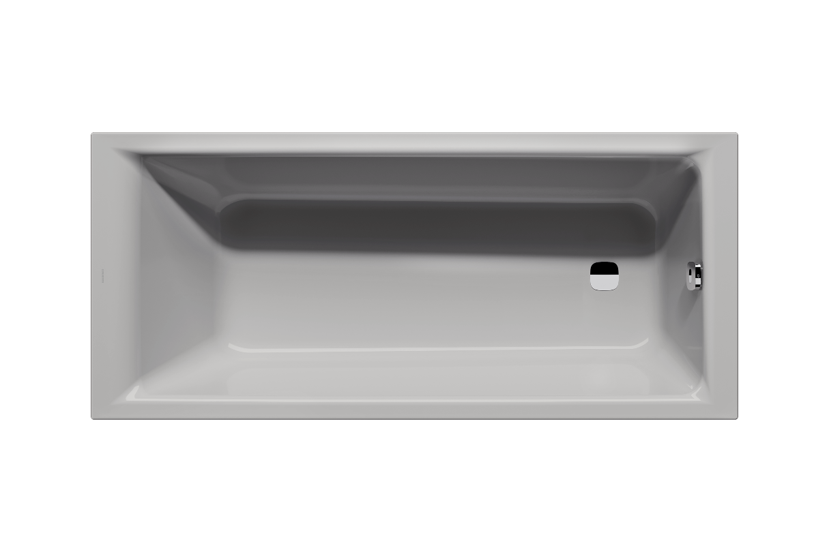
Photo: KALDEWEI

Kaldewei Puro Next in the colour manhattan: The Kaldewei Puro Next single-seater bathtub offers individual bathing comfort thanks to a generous lying surface.

About KALDEWEI
When it comes to the bathroom, many people immediately think of KALDEWEI - and for good reason: The premium brand stands for excellent solutions for the personal dream bathroom as well as for recyclable materials and products. Around 600 of them carry the Cradle to Cradle® Certified certificate and underline the company’s consistently sustainable orientation. KALDEWEI is one of the first German bathroom manufacturers with the Cradle to Cradle® Certified certification by an independent body. Bathtubs, washbasins, shower solutions – all KALDEWEI products made of steel and glass are plastic-free and promise individual sensual luxury. This is defined by sophisticated aesthetics, responsible longevity and lasting joy in use. And this can be even increased: exclusive spa facilities pamper all the senses and transform the bathroom into a true experience space. Under the term LUXSTAINABILITY® Kaldewei combines innovative design that evokes a special attitude to life and a deeply rooted sustainability that characterises all KALDEWEI products. The LUXSTAINABILITY® philosophy of the company enables individual luxury for the senses and for every budget – for the first-class top hotels as well as for comfortable private bathrooms.

Press contacts:

Franz Kaldewei GmbH & Co. KG Tel. +49 2382 785 209
Marcus Möllers Fax +49 2382 785 8209
PO Box 1761 marcus.moellers@kaldewei.de
59206 Ahlen, Germany www.kaldewei.com

Claudia Wünsch Communication GmbH Tel: +49 30 78956825
Massimiliano Monteverdi Fax:+49 30 69531380
Silbersteinstraße 45 mm@claudia-wuensch.com
12051 Berlin www.claudia-wuensch.com

UK press contact:

Esprit Media Ltd. Tel. +44 1428 788 098
Karen Brooks karen@espritpr.com
Stephanie Edwards-Morgan stephanie@espritpr.com
The old Chicken Shed
Kiln Cottage, Kiln Way
Grayshott
Hampshire, England

Further information and illustrations are available from Kaldewei’s virtual press office: www.kaldewei.com

