Delicate Classic Composition in Duo
The Kaldewei Meisterstück Classic Duo Oval now in a slender design

KALDEWEI, Ahlen, March 2025 - With the Meisterstück Classic Duo Oval, Kaldewei presents the epitome of the free-standing bathtub in a new lightness: the narrower edge of the tub allows the classic beauty to shine delicately, while the monolithic appearance conveys timeless elegance. Made from a single piece and featuring the highest quality materials, this bathtub is the perfect choice for anyone who appreciates stylish aesthetics and uncompromising quality.
Individual touch for a harmonious bathroom composition
Kaldewei Meisterstück Classic Duo Oval impresses with its understated design language and harmonious colours. The new waste and overflow fitting in a seamless look provides an aesthetic and functional highlight. The free-standing bathtub is available in classic alpine white as well as in eight elegant matt colours from the Coordinated Colours Collection, which give every room an individual touch. With three dimensions, the bathtub fits perfectly into a wide variety of room concepts. Thanks to the tapered shape, two comfortable backrests and the central waste, the Meisterstück Classic Duo Oval offers maximum comfort even for two.
An elegant statement for stylish living
The slender aesthetics of the Kaldewei Meisterstück Classic Duo Oval bring lightness to every room. Kaldewei combines individual luxury and quality with artistic workmanship to perfection. The new free-standing Meisterstück Classic Duo Oval bathtub from Kaldewei – an elegant statement for stylish living and pure enjoyment.

Images and captions:

3.1_Kaldewei_MST_ClassicDuoOval_WG60
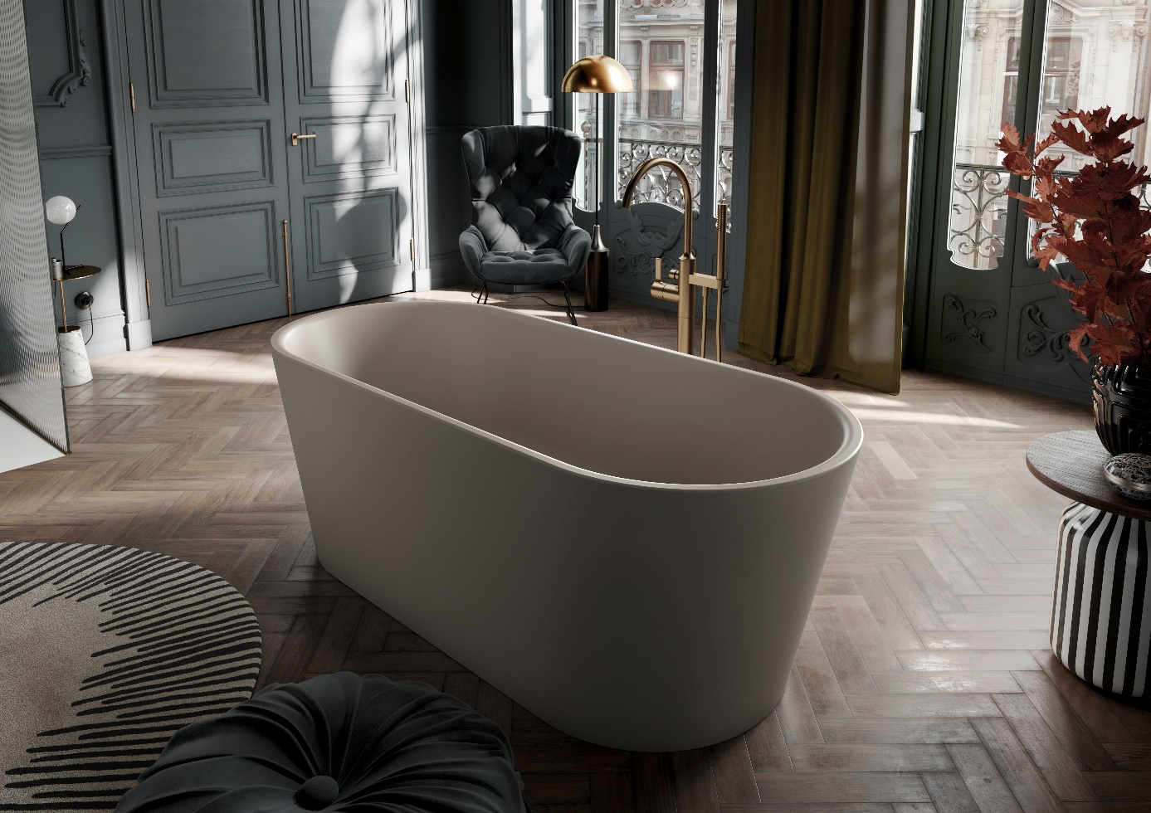
Photo: KALDEWEI

The slender aesthetics of the Kaldewei Meisterstück Classic Duo Oval bring lightness to every room.

3.2_Kaldewei_MST_ClassicDuoOval_WG60
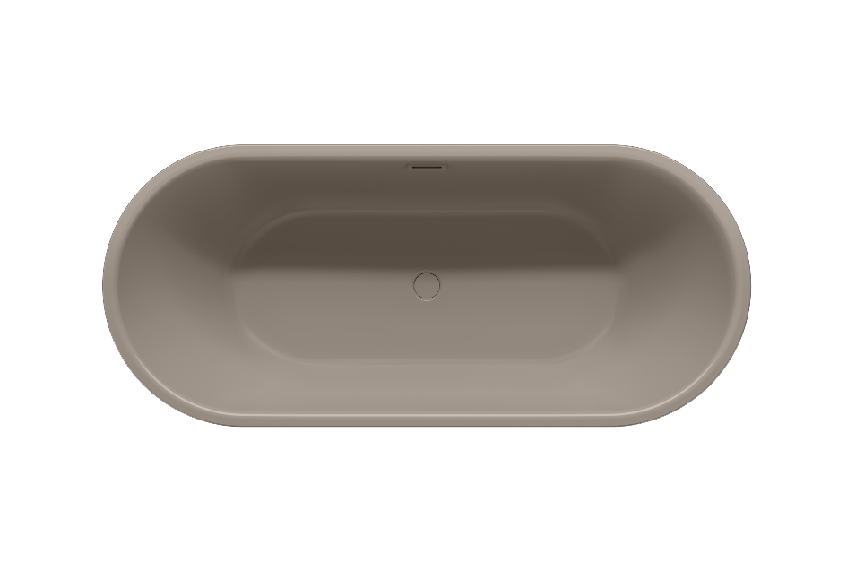
Photo: KALDEWEI

Kaldewei Meisterstück Classic Duo Oval in the colour warm grey 60

3.3_Kaldewei_MST_ClassicDuoOval_WG60
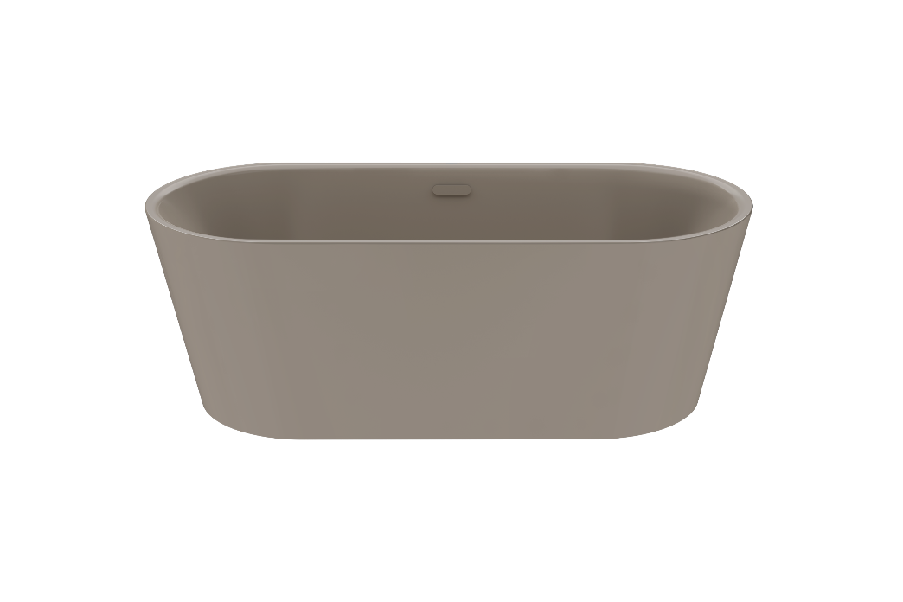
Photo: KALDEWEI

Kaldewei Meisterstück Classic Duo Oval in the colour warm grey 60
3.4_Kaldewei_MST_ClassicDuoOval_AW
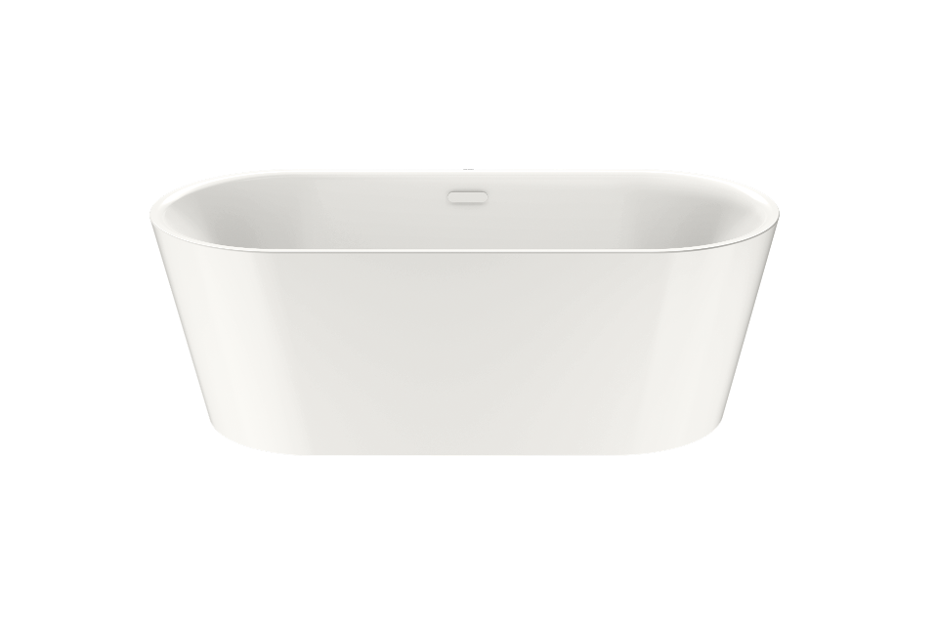
Photo: KALDEWEI

Kaldewei Meisterstück Classic Duo Oval in the colour alpine white

3.5_Kaldewei_MST_ClassicDuoOval_AWmatt
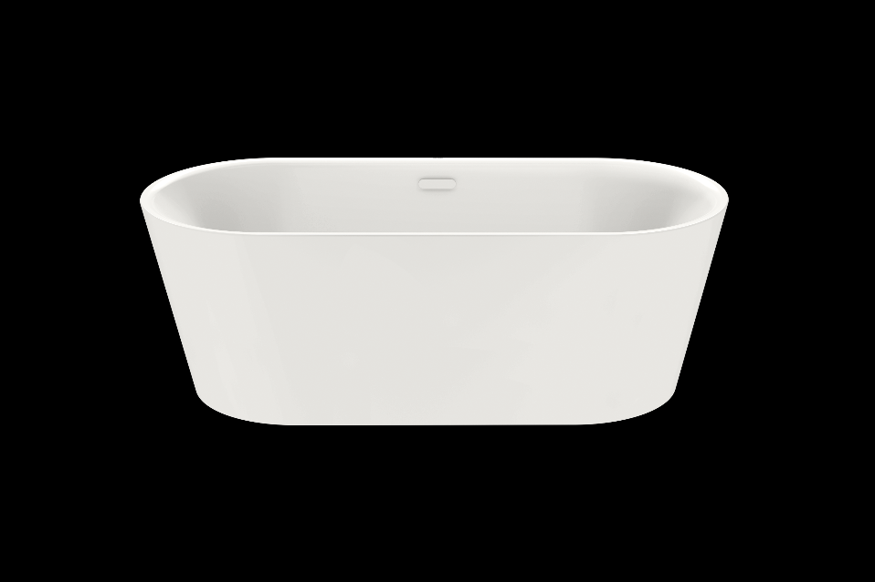
Photo: KALDEWEI

Kaldewei Meisterstück Classic Duo Oval in the colour alpine white matt

3.6_Kaldewei_MST_ClassicDuoOval_CG30
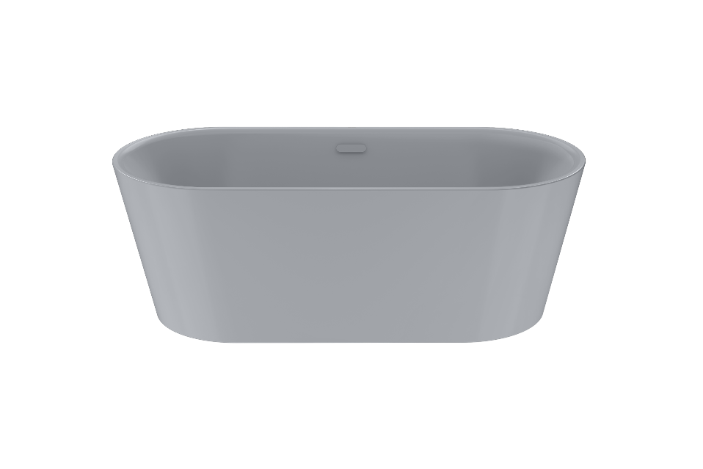
Photo: KALDEWEI

Kaldewei Meisterstück Classic Duo Oval in the colour cool grey 30

3.7_Kaldewei_MST_ClassicDuoOval_CG70
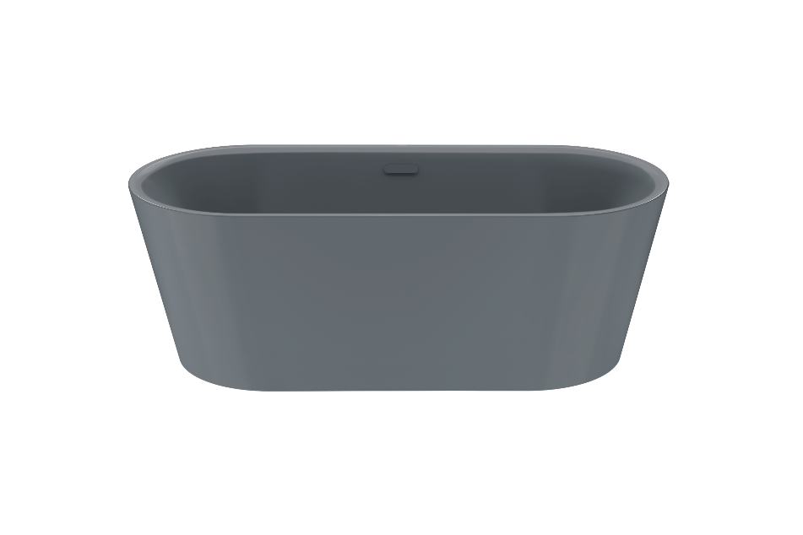
Photo: KALDEWEI

Kaldewei Meisterstück Classic Duo Oval in the colour cool grey 70

3.8_Kaldewei_MST_ClassicDuoOval_CG90
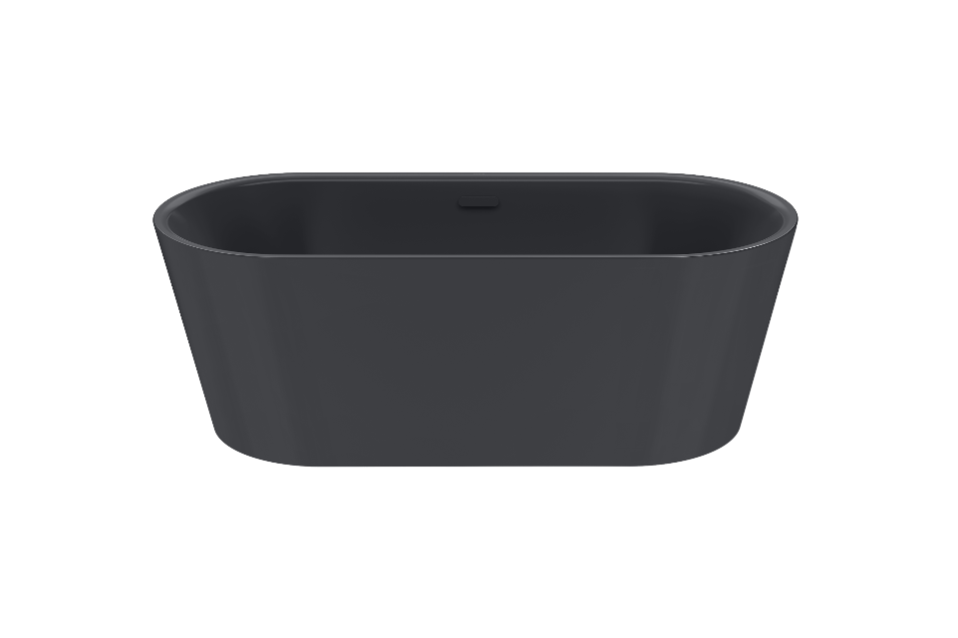
Photo: KALDEWEI

Kaldewei Meisterstück Classic Duo Oval in the colour cool grey 90

3.9_Kaldewei_MST_ClassicDuoOval_Smatt
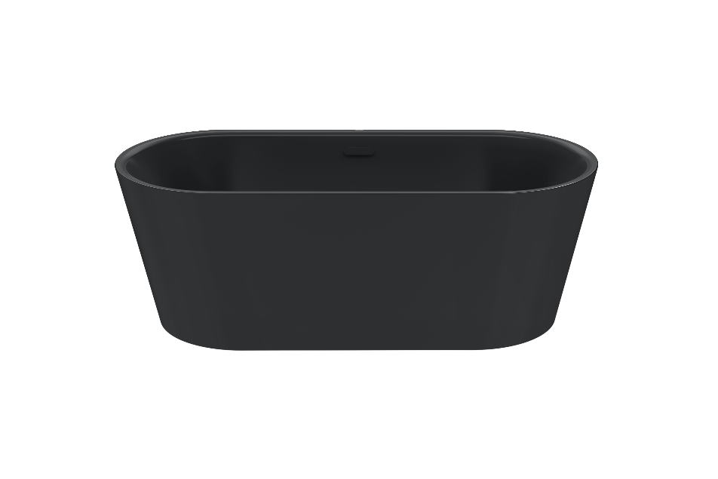
Photo: KALDEWEI

Kaldewei Meisterstück Classic Duo Oval in the colour black matt

3.10_Kaldewei_MST_ClassicDuoOval_WB20
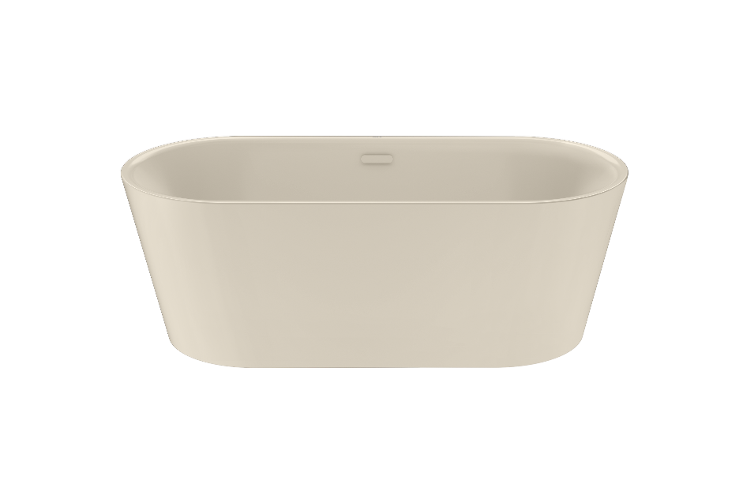
Photo: KALDEWEI

Kaldewei Meisterstück Classic Duo Oval in the colour warm beige 20

3.11_Kaldewei_MST_ClassicDuoOval_WG10
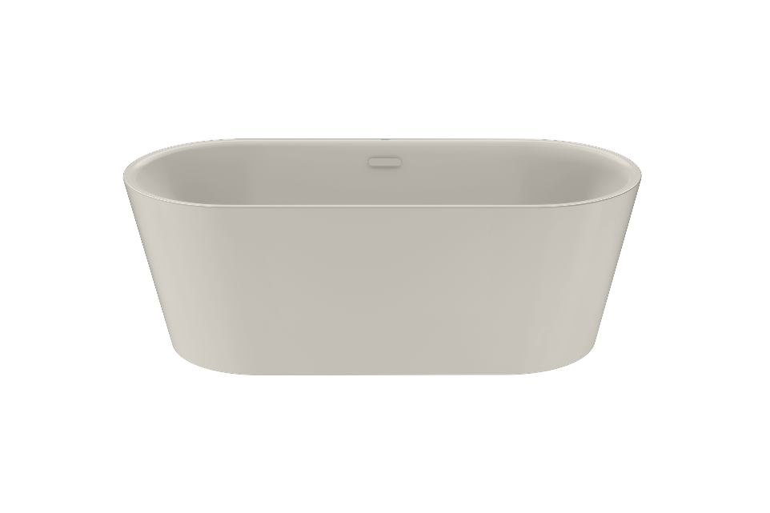
Photo: KALDEWEI

Kaldewei Meisterstück Classic Duo Oval in the colour warm grey 10

About KALDEWEI
When it comes to the bathroom, many people immediately think of KALDEWEI - and for good reason: The premium brand stands for excellent solutions for the personal dream bathroom as well as for recyclable materials and products. Around 600 of them carry the Cradle to Cradle® Certified certificate and underline the company’s consistently sustainable orientation. KALDEWEI is one of the first German bathroom manufacturers with the Cradle to Cradle® Certified certification by an independent body. Bathtubs, washbasins, shower solutions – all KALDEWEI products made of steel and glass are plastic-free and promise individual sensual luxury. This is defined by sophisticated aesthetics, responsible longevity and lasting joy in use. And this can be even increased: exclusive spa facilities pamper all the senses and transform the bathroom into a true experience space. Under the term LUXSTAINABILITY® Kaldewei combines innovative design that evokes a special attitude to life and a deeply rooted sustainability that characterises all KALDEWEI products. The LUXSTAINABILITY® philosophy of the company enables individual luxury for the senses and for every budget – for the first-class top hotels as well as for comfortable private bathrooms.

Press contacts:

Franz Kaldewei GmbH & Co. KG Tel. +49 2382 785 209
Marcus Möllers Fax +49 2382 785 8209
PO Box 1761 marcus.moellers@kaldewei.de
59206 Ahlen, Germany www.kaldewei.com

Claudia Wünsch Communication GmbH Tel: +49 30 78956825
Massimiliano Monteverdi Fax:+49 30 69531380
Silbersteinstraße 45 mm@claudia-wuensch.com
12051 Berlin www.claudia-wuensch.com

UK press contact:

Esprit Media Ltd. Tel. +44 1428 788 098
Karen Brooks karen@espritpr.com
Stephanie Edwards-Morgan stephanie@espritpr.com
The old Chicken Shed
Kiln Cottage, Kiln Way
Grayshott
Hampshire, England

Further information and illustrations are available from Kaldewei’s virtual press office: www.kaldewei.com

