Kaldewei Nuio Duo: Pure relaxation and timeless aesthetics, perfectly combined
New design bathtub in the Zen Edition ensures holistic regeneration with innovative features
KALDEWEI, Ahlen, March 2025 - The new Kaldewei Nuio Duo designer bathtub adds elegance to any bathroom. With the high-end features of the Zen Edition such as infrared heat, music, light and intuitive operation, the beauty invites you to leave everyday life behind and immerse yourself completely in the moment. The water envelops the body, the innovative features pamper the senses and ensure holistic regeneration.
It’s not just about bathing – the Kaldewei Nuio Duo is a stylish upgrade for any bathroom. This creates a place where aesthetics meet pure relaxation and every moment becomes a gift to yourself. Kaldewei Nuio Duo in the Zen Edition appeals to all the senses: Water caresses the skin, infrared heat relieves tension, gentle lighting soothes the eyes, and the ability actually to feel music creates a feeling of security.
“Immersive tub” for a holistic bathing experience
The Kaldewei Heat Wave is one of the outstanding innovations. This combines soothing and precisely adjustable infrared radiant heat with an ergonomic tub shape that gently accommodates the body and supports it perfectly. The balanced synergy of heat and water not only creates a pleasant atmosphere, but also promotes relaxation and has a positive effect on muscles and bones thanks to targeted infrared heat. This leads to a new experience of emotional and physical relaxation and creates a feeling of inner and outer harmony. The Kaldewei Nuio Duo in the Zen Edition becomes an “immersive tub” for a particularly intensive and holistic bathing experience.
Elegant control panel with LCD display and slider function
Heat Wave, Sound Wave, various lighting moods with a wide colour spectrum and other practical functions: all elements of the Zen Edition can be controlled and individually adjusted via an elegant control panel. The modern LCD display with intuitive slider function shows the current settings including the water temperature. The panel combines comfort with aesthetics - it is easily accessible, ensures easy filling of the tub and also stylishly integrates the overflow.
Inspired by nature
Designer Stefan Diez is responsible for the clear lines of the Kaldewei Nuio Duo. It integrates discreetly and harmoniously into the bathroom ambience, but can also emphasise its special character as a design eye-catcher thanks to its sculptural presence. The flowing shape is reminiscent of pools created by water and combines natural geometry with modern minimalism. Generous dimensions, ergonomic back sections and the pronounced neck and shoulder area ensure luxurious comfort in the deep bathtub. The sophisticated Kaldewei material stands for longevity and sustainability.
Statement for enjoyment and relaxation
The Kaldewei Nuio Duo is more than just a bathtub – it is a statement for modern enjoyment, for the art of relaxation and for the joy of innovative aesthetics. It combines beauty with intelligent technologies and creates a space in which relaxation is redefined.

Images and captions:

2.1_Kaldewei_NuioDuo_ZEN_CG90

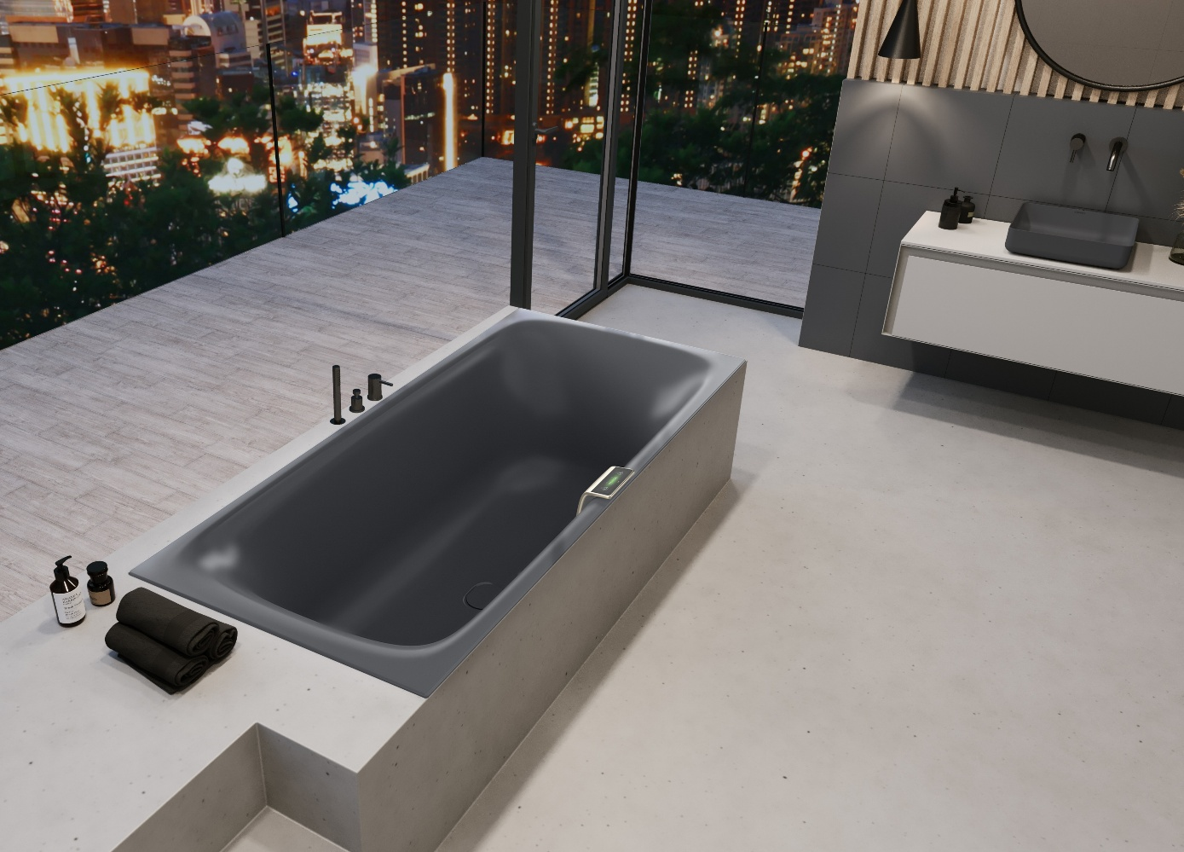
Photo: KALDEWEI

The Kaldewei Nuio Duo adds elegance to any bathroom. The high-end features of the Zen Edition invite you to leave everyday life behind and immerse yourself completely in the moment.

2.2_Kaldewei_NuioDuo_ZEN_WB20
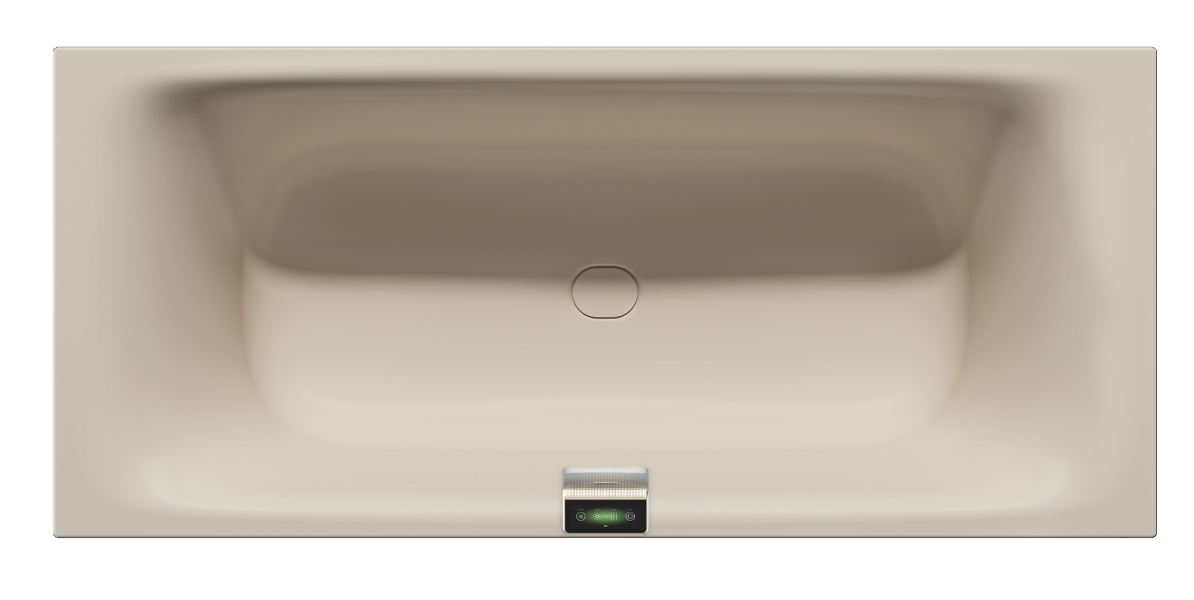Photo: KALDEWEI

All elements of the Zen Edition can be controlled and individually adjusted via an elegant control panel.

2.3_Kaldewei_ NuioDuo_ZEN_Panel

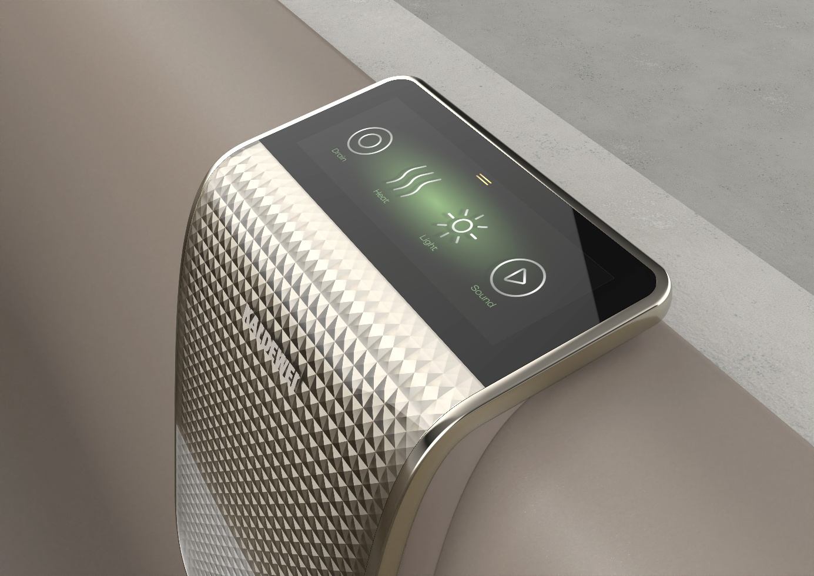
Photo: KALDEWEI

The modern LCD display with intuitive slider function shows the current settings including the water temperature.

2.4_Kaldewei_NuioDuo_WG60

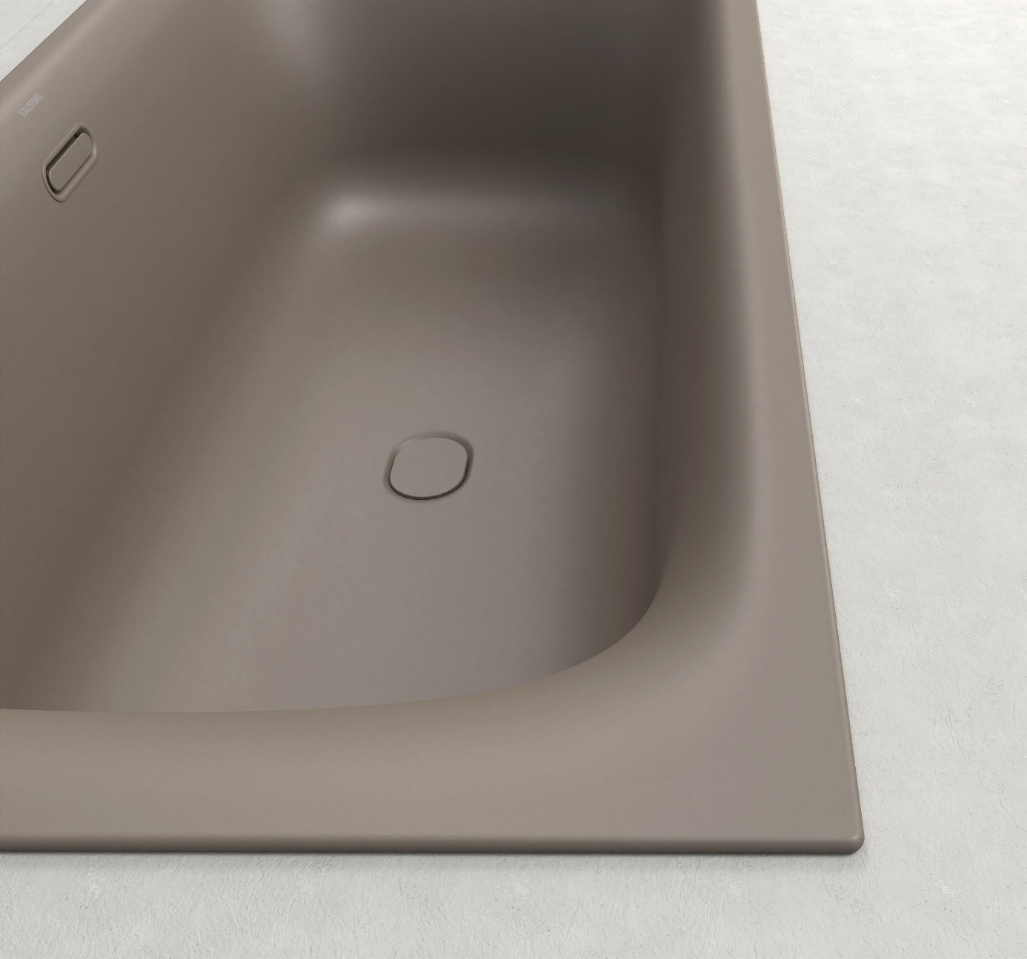
Photo: KALDEWEI

Generous dimensions, ergonomic back sections and the pronounced neck and shoulder area ensure luxurious comfort in the deep bathtub.

2.5_Kaldewei_NuioDuo_WG60

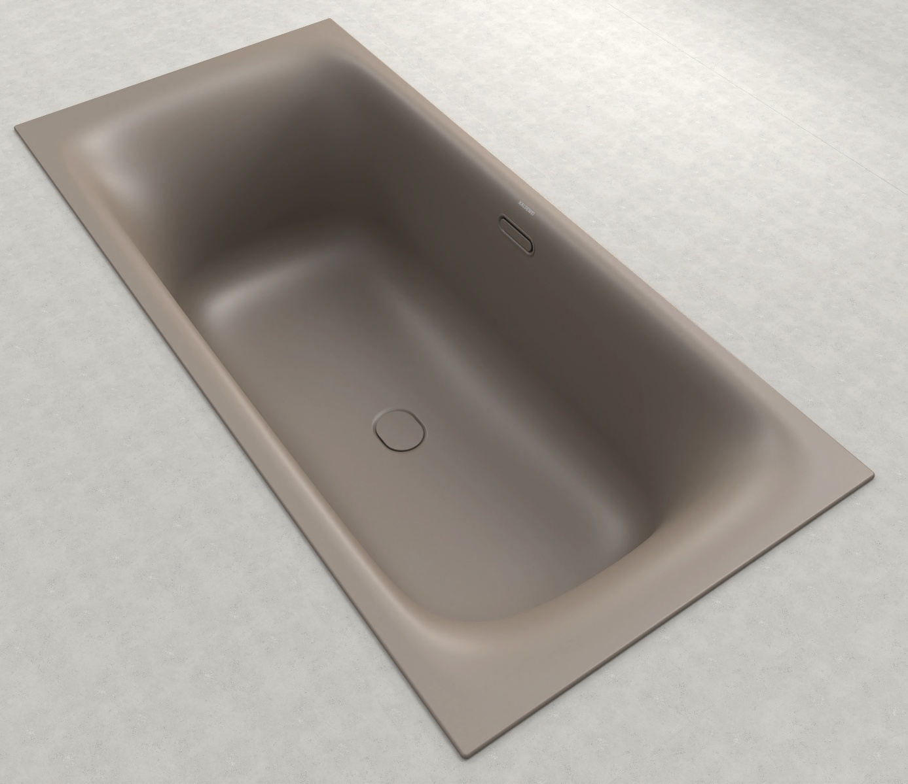
Photo: KALDEWEI

The flowing shape is reminiscent of pools created by water and combines natural geometry with modern minimalism.

2.6_Kaldewei_NuioDuo_ZEN_CG30
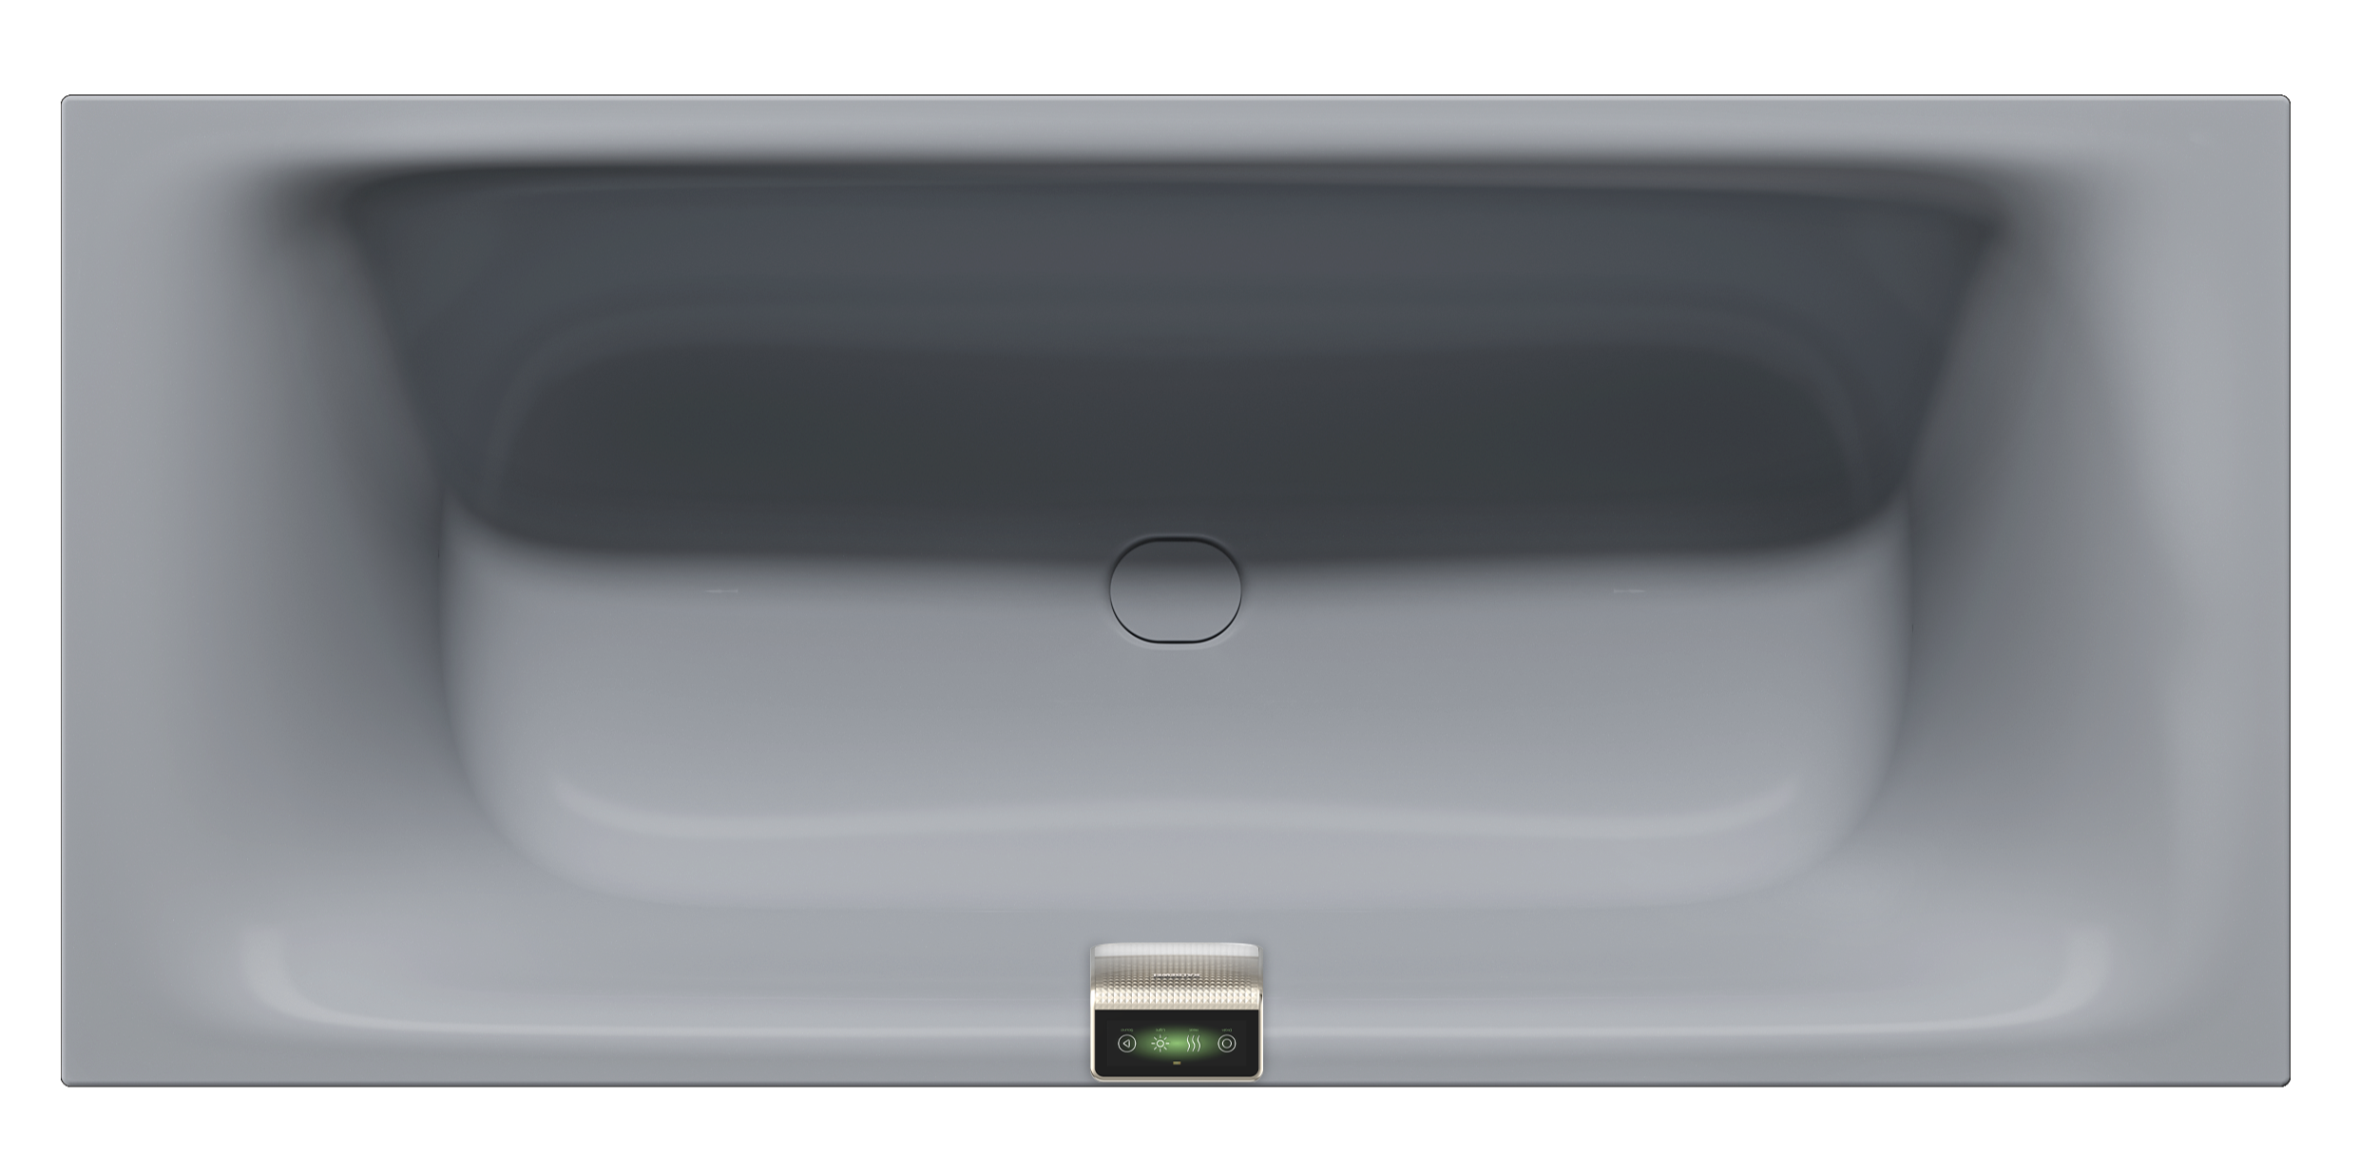Photo: KALDEWEI

Designer Stefan Diez is responsible for the clear lines of the Nuio Duo.

2.7_Kaldewei_NuioDuo_ZEN_AW
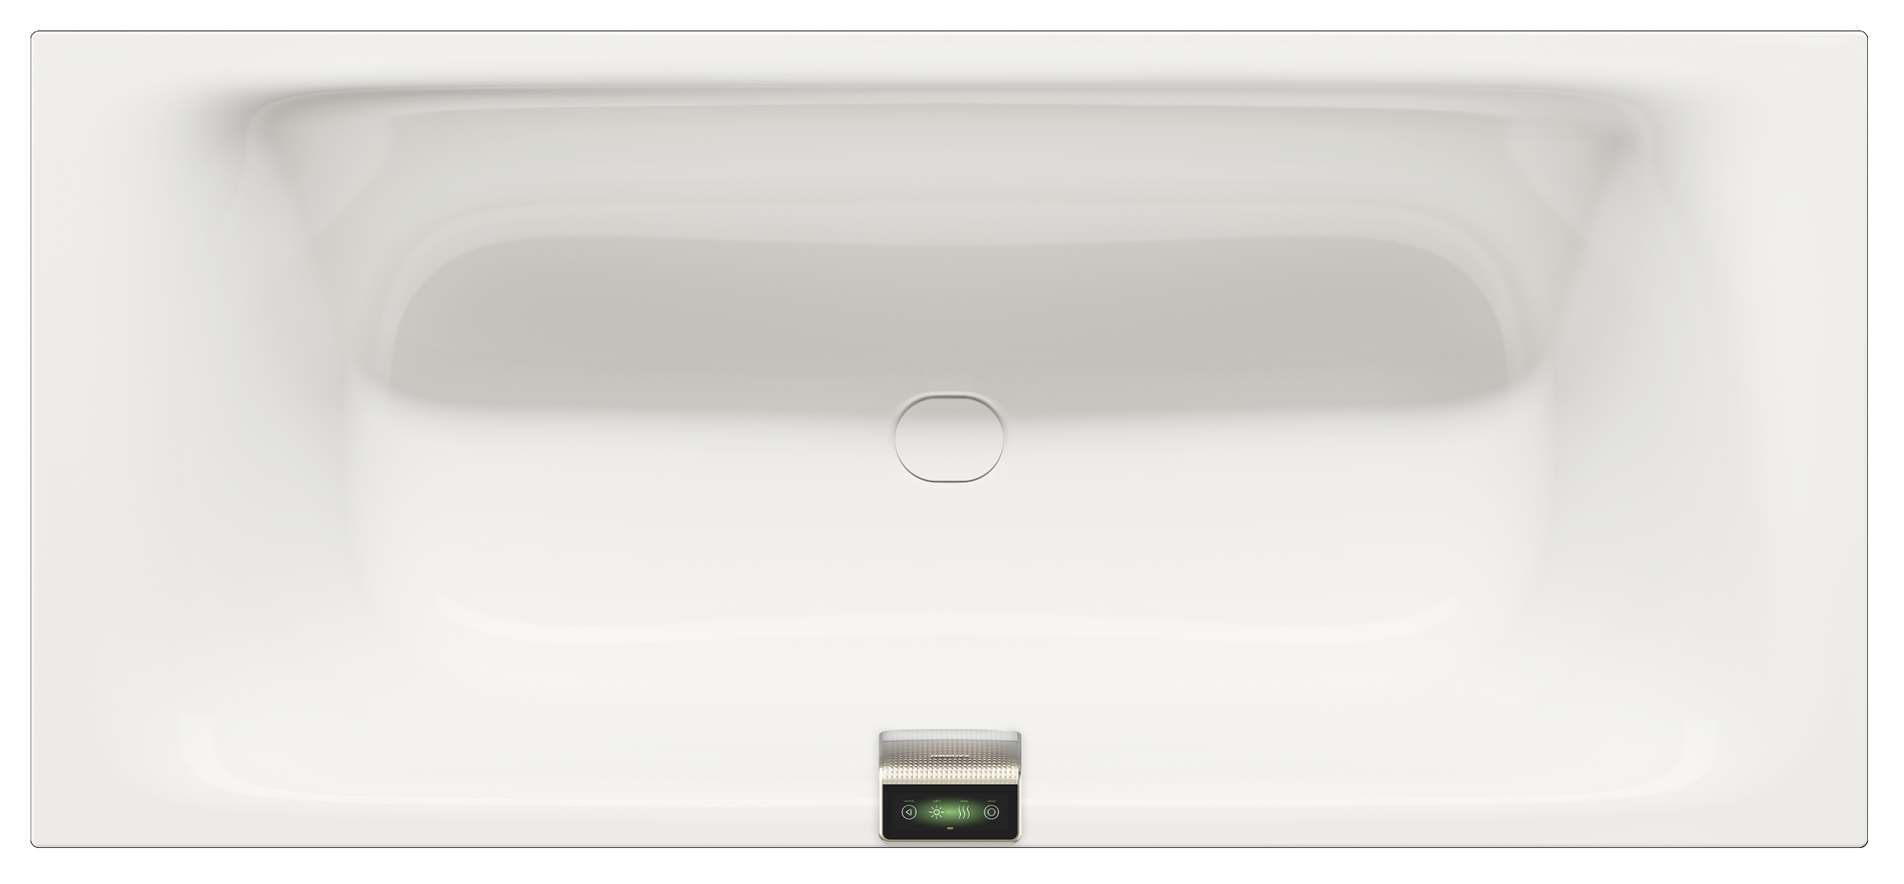
Photo: KALDEWEI

The Kaldewei Nuio Duo is more than just a bathtub – it is a statement for modern enjoyment, for the art of relaxation and for the joy of innovative aesthetics.

2.8_Kaldewei_NuioDuo_WG10
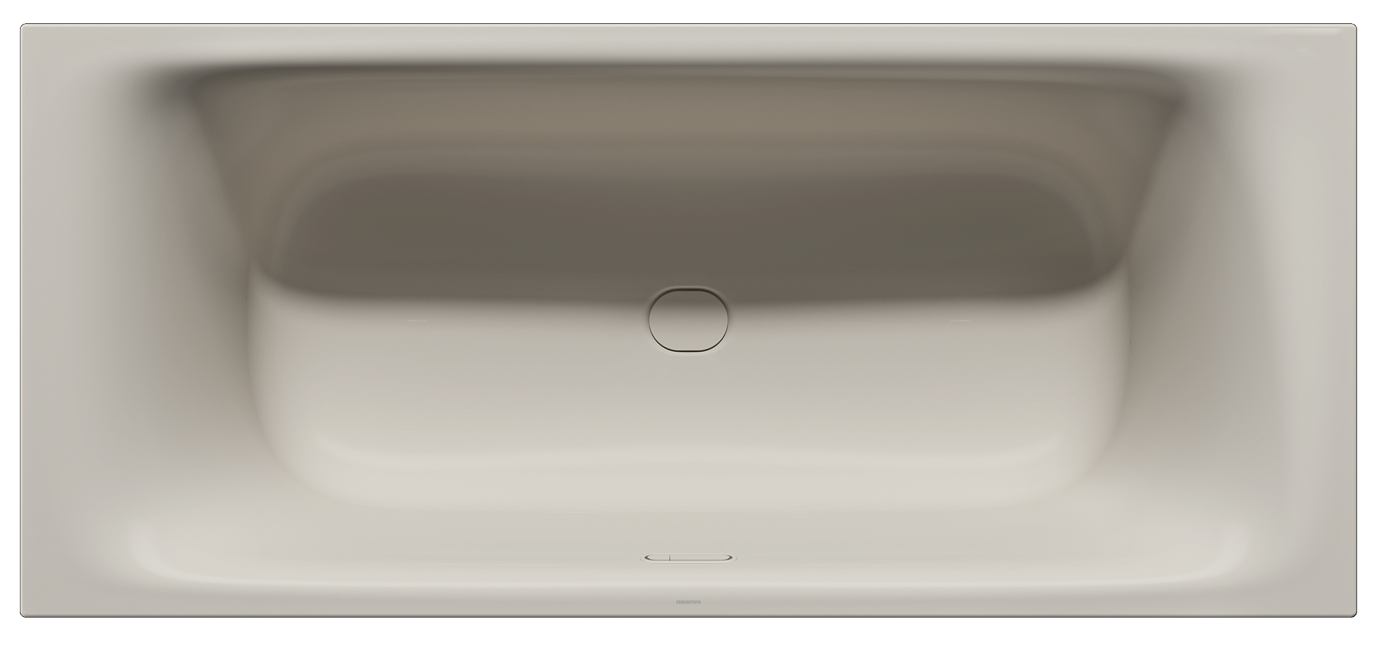
Photo: KALDEWEI
Kaldewei Nuio Duo in warm grey 10

2.9_Kaldewei_NuioDuo_CG70
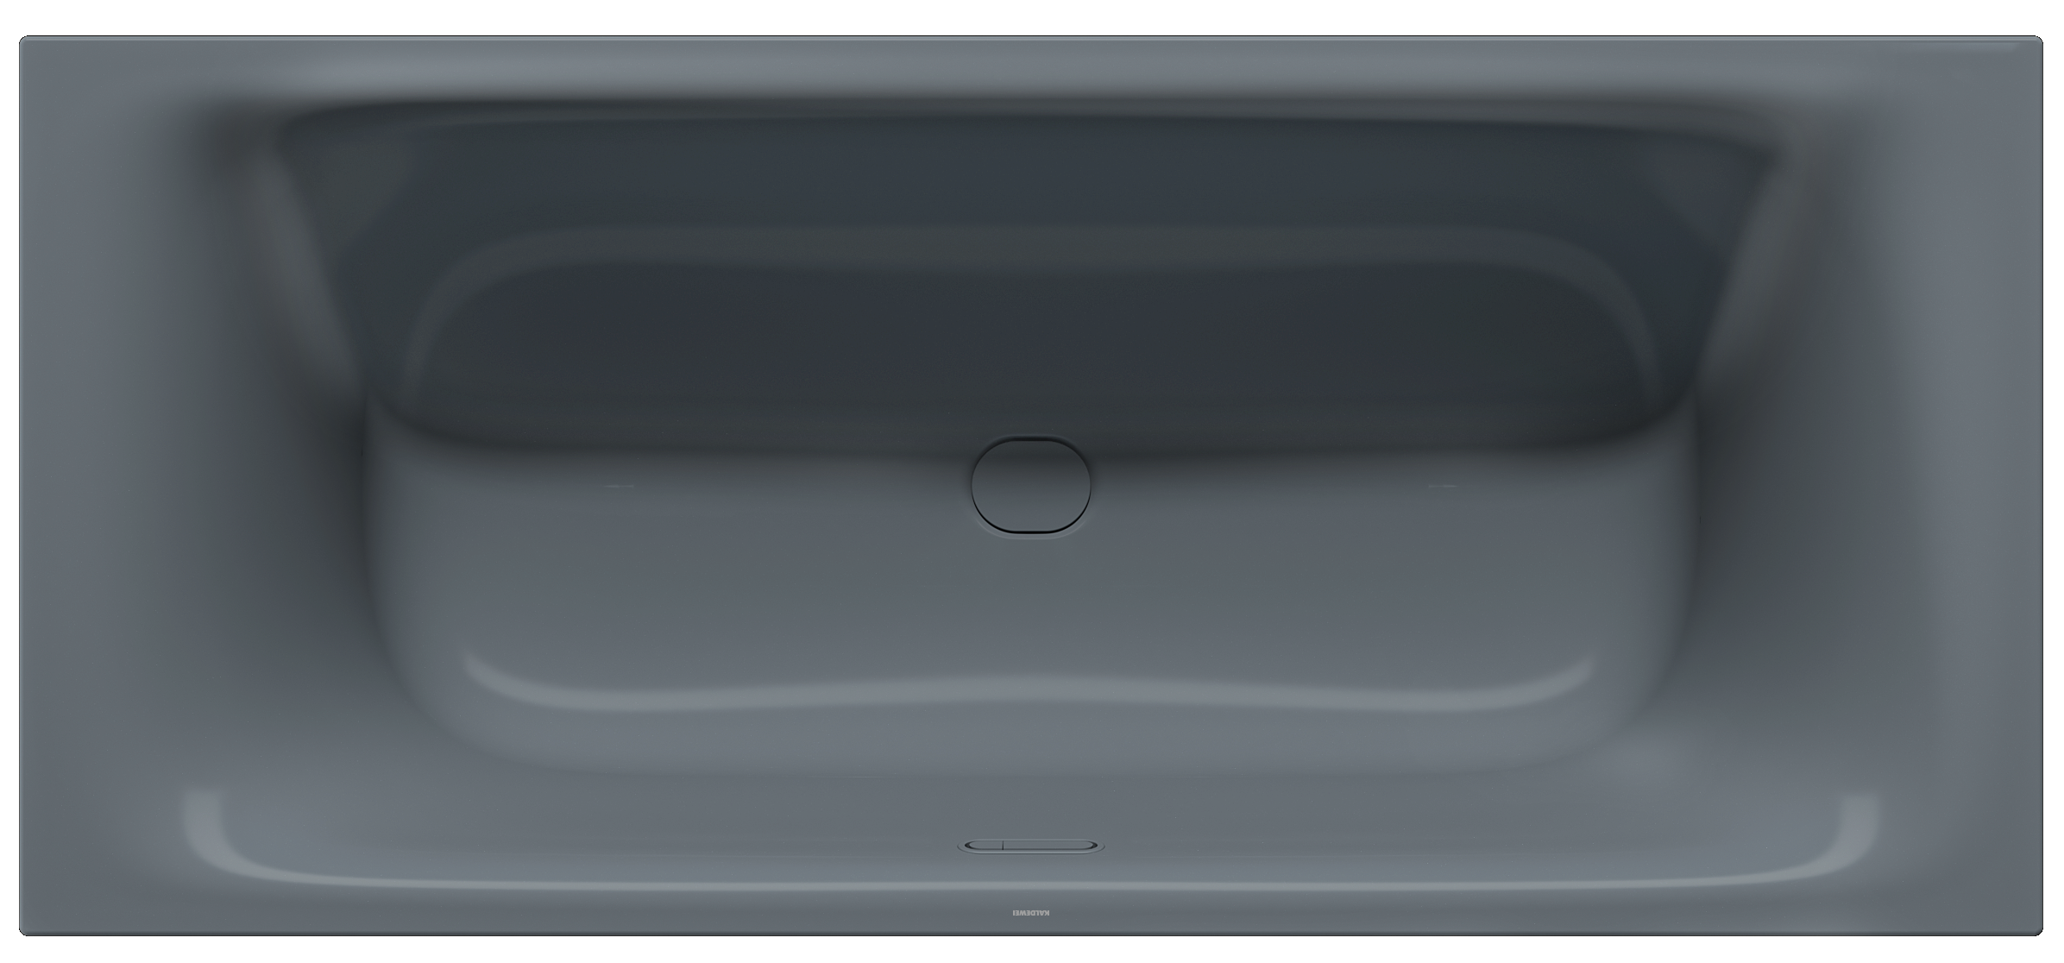
Photo: KALDEWEI
Kaldewei Nuio Duo in cool grey 70

About KALDEWEI
When it comes to the bathroom, many people immediately think of KALDEWEI - and for good reason: The premium brand stands for excellent solutions for the personal dream bathroom as well as for recyclable materials and products. Around 600 of them carry the Cradle to Cradle® Certified certificate and underline the company’s consistently sustainable orientation. KALDEWEI is one of the first German bathroom manufacturers with the Cradle to Cradle® Certified certification by an independent body. Bathtubs, washbasins, shower solutions – all KALDEWEI products made of steel and glass are plastic-free and promise individual sensual luxury. This is defined by sophisticated aesthetics, responsible longevity and lasting joy in use. And this can be even increased: exclusive spa facilities pamper all the senses and transform the bathroom into a true experience space. Under the term LUXSTAINABILITY® Kaldewei combines innovative design that evokes a special attitude to life and a deeply rooted sustainability that characterises all KALDEWEI products. The LUXSTAINABILITY® philosophy of the company enables individual luxury for the senses and for every budget – for the first-class top hotels as well as for comfortable private bathrooms.

Press contacts:

Franz Kaldewei GmbH & Co. KG Tel. +49 2382 785 209
Marcus Möllers Fax +49 2382 785 8209
PO Box 1761 marcus.moellers@kaldewei.de
59206 Ahlen, Germany www.kaldewei.com

Claudia Wünsch Communication GmbH Tel: +49 30 78956825
Massimiliano Monteverdi Fax:+49 30 69531380
Silbersteinstraße 45 mm@claudia-wuensch.com
12051 Berlin www.claudia-wuensch.com

UK press contact:

Esprit Media Ltd. Tel. +44 1428 788 098
Karen Brooks karen@espritpr.com
Stephanie Edwards-Morgan stephanie@espritpr.com
The old Chicken Shed
Kiln Cottage, Kiln Way
Grayshott
Hampshire, England

Further information and illustrations are available from Kaldewei’s virtual press office: www.kaldewei.com

