Kaldewei SolidliteTM:
New material technology simplifies the work of plumbing professionals
Familiar, routine installation steps – light and stable material –
ideal for skilled trade professionals

KALDEWEI, Ahlen, March 2025 – Kaldewei SolidliteTM showers put an end to heavy lifting and complicated installation, as well as to annoying material breakages, warping or hairline cracks, which many plumbing professionals report in their daily work. Showers made from a sensitive composite material, such as polyester resin and mineral fillers, are considered particularly vulnerable. They regularly present plumbing trade professionals with unplanned challenges on the construction site. The new SolidliteTM Kaldewei products provide an answer to this and, in addition to the usual quality of Kaldewei products, also promise to make work easier for those in the trade. Kaldewei SolidliteTM showers can be installed very easily, safely and quickly, and their impeccable surface is also impressive.
What counts for the installer is what convinces in practice every day – and that is exactly what drove Kaldewei’s development. The result: a shower made of Kaldewei SolidliteTM, which impresses with its low weight, exceptional stability and a first-class surface. The result is a shower surface in proven Kaldewei quality, filled with recycled glass. This core provides the special properties of SolidliteTM products: no warping, no breaking, no complicated installation. And the bathroom professionals can convince themselves of the effortless transport and easy handling on the construction site in practical tests.
The installation of Kaldewei shower surfaces with SolidliteTM technology is simple and routine with the usual installation steps. Whether directly on the floor or on adjustable feet – installation is quick, precise and safe. Neither time-consuming alignment work nor additional sound insulation is required. Even difficult floor plans are no problem: Kaldewei SolidliteTM can be customised to the centimetre for any installation situation, as the shower surface can be cut to size at the factory.

Kaldewei Calima – convincing design
The new Kaldewei Calima shower surface with SolidliteTM technology is specially tailored to the requirements of international markets. It combines modern design and quality with practical installation advantages for the plumbing trade professional. Kaldewei Calima is defined by a clear, minimalist design: Step-free transitions with an invisible water edge on three sides as well as precise corner radii create an elegant, floor-level look. The waste is located outside the base on the short side and is bordered towards the edge by a design-defining edge. This not only serves as a visual element, but also ensures that the water is drained away safely.
Easy installation – reliable durability
The Kaldewei Calima shower surface with SolidliteTM technology is particularly trade professional-friendly thanks to its stable core made of recycled glass – easy to transport, easy to handle and quick to install. Available in 44 sizes from 70 cm to 180 cm side length and in five elegant colours – alpine white, alpine white matt, warm beige, cool grey and black matt – the Kaldewei Calima adapts to every room situation and every design concept. Their consistent depth across all dimensions ensures reliable planning and installation.
The shower surface also provides long-term safety. Even after years of intensive use, the elegant surface remains permanently sealed and protects against hairline cracks or material breakage. A great gain for trade professionals and customers alike.
The future begins now
Kaldewei's material expertise is evident in the Kaldewei Calima with SolidliteTM technology also in the area of sustainability: The core of the revolutionary material is made from recycled glass, making the entire shower completely recyclable. This is good for the ecological footprint of new construction and renovation and is good for future generations. With Kaldewei SolidliteTM plumbing professionals experience a new dimension of work: easier, faster, safer. A shower surface that understands exactly what the trade professional on the construction site needs – and that exceeds many expectations. Kaldewei SolidliteTM is a promising product for the future of the plumbing trade.

Images and captions:

1.1.1_Kaldewei_Calima_AWm
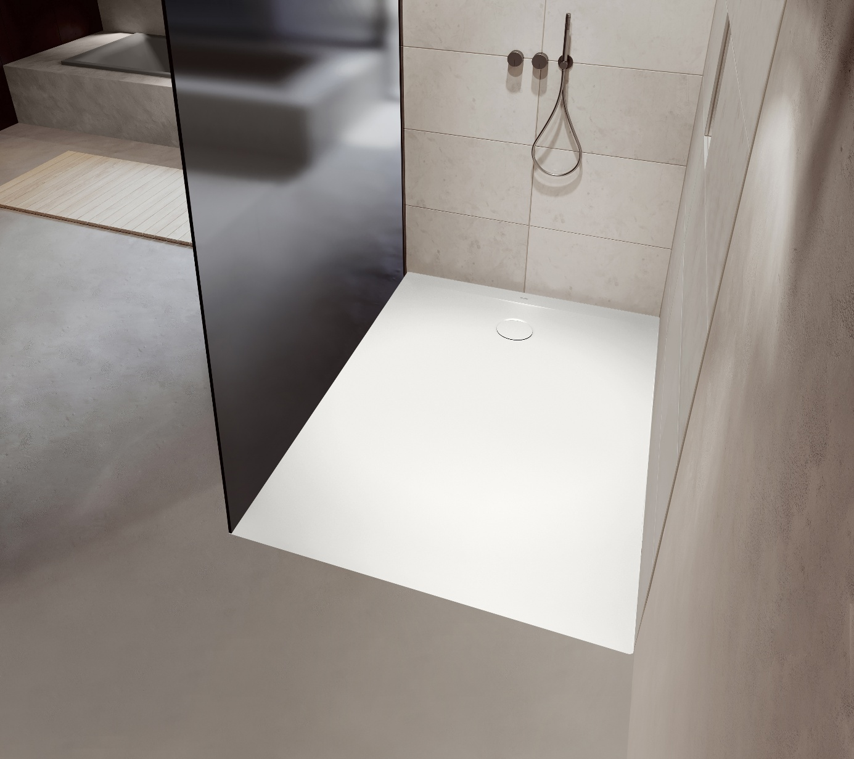

Photo: KALDEWEI

The new Kaldewei Calima shower surface with SolidliteTM technology is specially tailored to the requirements of international markets.

1.1.2_Kaldewei_Calima_ CG30
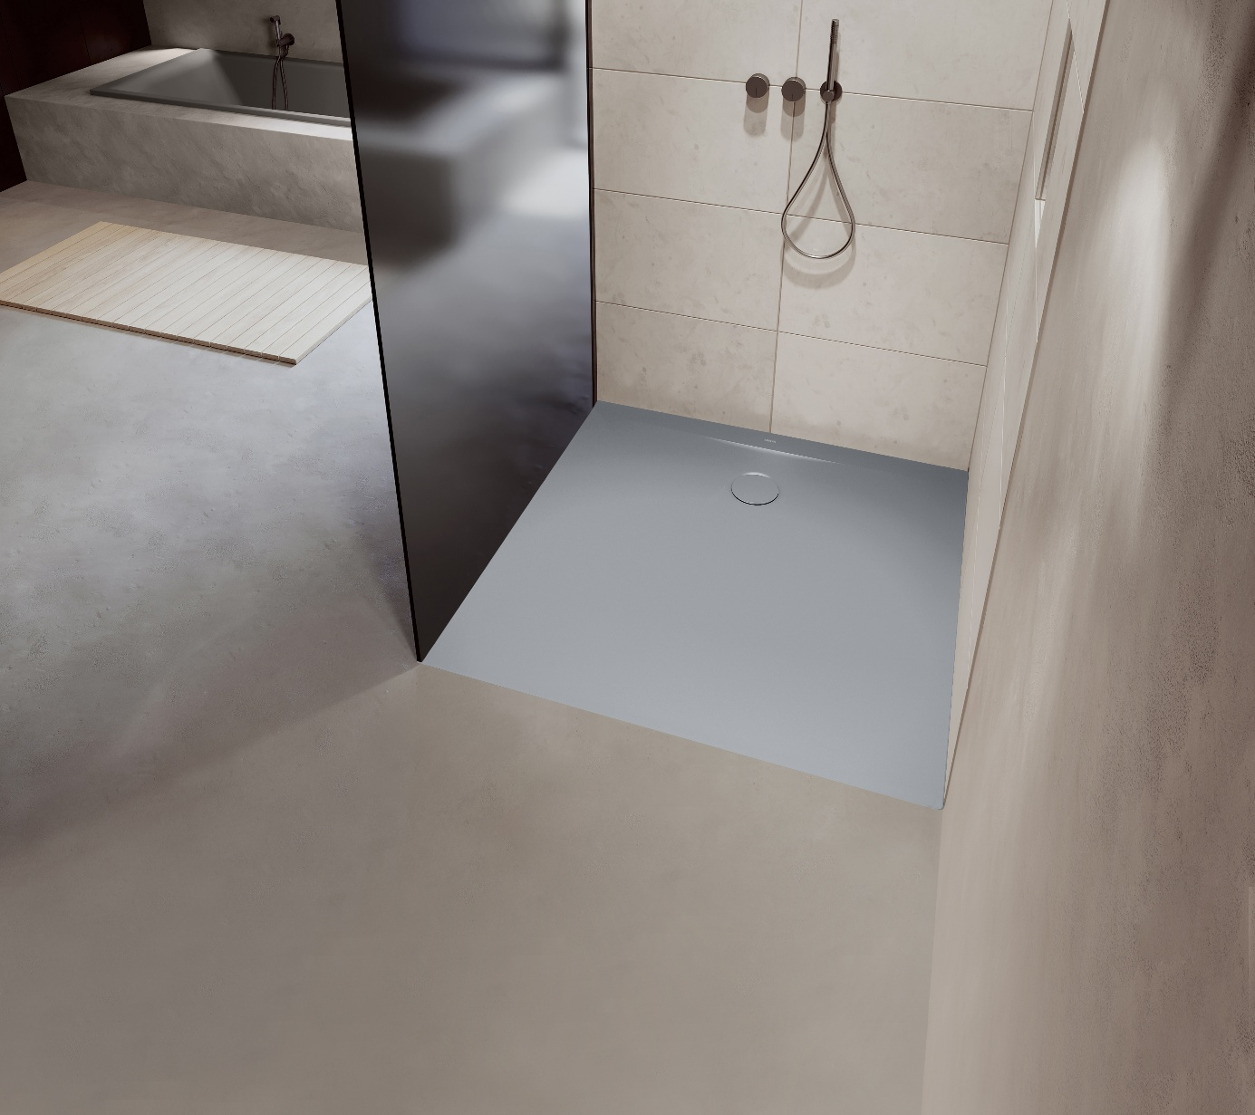
Photo: KALDEWEI

Kaldewei Calima is defined by a clear, minimalist design: Step-free transitions and precise corner radii create an elegant, floor-level appearance.

1.1.3_Kaldewei_Calima_WB20
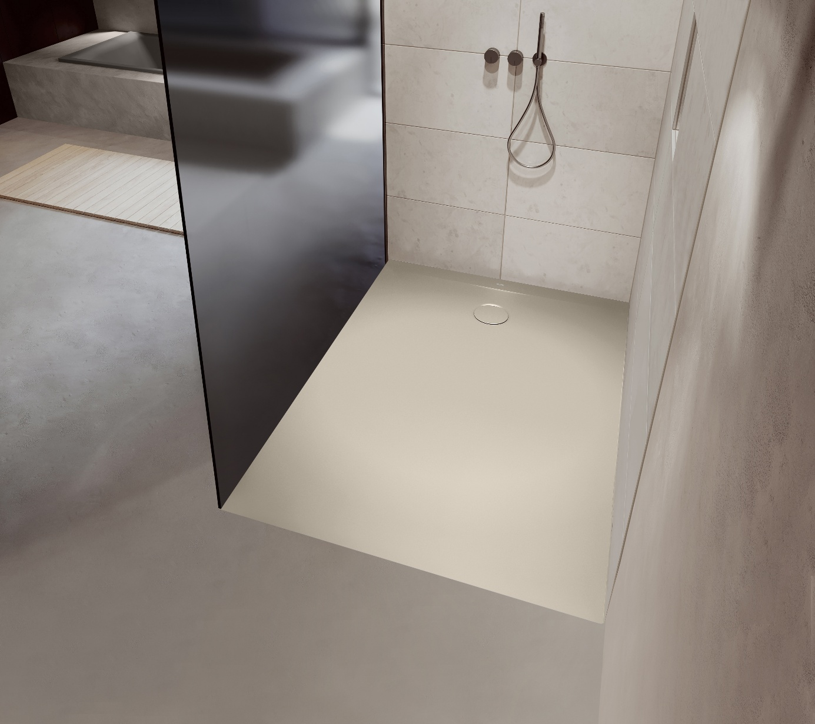
Photo: KALDEWEI

Kaldewei SolidliteTM showers can be installed very easily, safely and quickly, and their impeccable surface is also impressive.

1.1.4_Kaldewei_Calima_AW
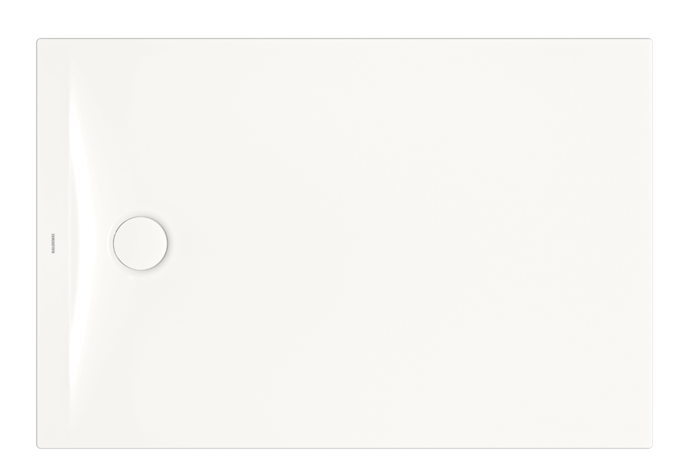
Photo: KALDEWEI

The waste is located outside the base on the short side and is bordered towards the edge by a design-defining edge.

1.1.5_Kaldewei_Calima
Photo: KALDEWEI

The Kaldewei Calima shower surface with SolidliteTM technology is particularly trade professional-friendly thanks to its stable core made of recycled glass – easy to transport, easy to handle and quick to install.

1.1.6_Kaldewei_Calima_Colours

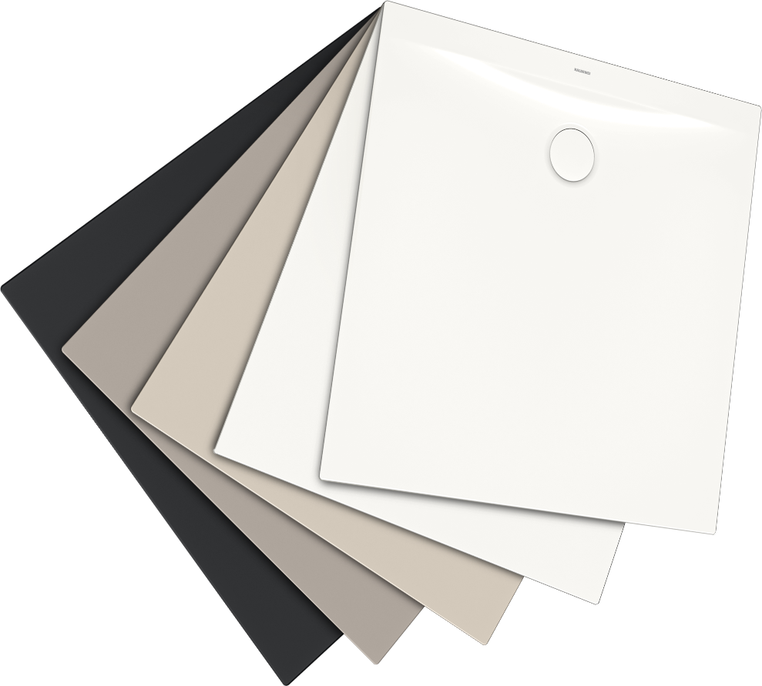
Photo: KALDEWEI

The Kaldewei Calima in SolidliteTM technology is available in 44 sizes and in five elegant colours – alpine white, alpine white matt, warm beige, cool grey and black matt.

About KALDEWEI
When it comes to the bathroom, many people immediately think of KALDEWEI - and for good reason: The premium brand stands for excellent solutions for the personal dream bathroom as well as for recyclable materials and products. Around 600 of them carry the Cradle to Cradle® Certified certificate and underline the company’s consistently sustainable orientation. KALDEWEI is one of the first German bathroom manufacturers with the Cradle to Cradle® Certified certification by an independent body. Bathtubs, washbasins, shower solutions – all KALDEWEI products made of steel and glass are plastic-free and promise individual sensual luxury. This is defined by sophisticated aesthetics, responsible longevity and lasting joy in use. And this can be even increased: exclusive spa facilities pamper all the senses and transform the bathroom into a true experience space. Under the term LUXSTAINABILITY® Kaldewei combines innovative design that evokes a special attitude to life and a deeply rooted sustainability that characterises all KALDEWEI products. The LUXSTAINABILITY® philosophy of the company enables individual luxury for the senses and for every budget – for the first-class top hotels as well as for comfortable private bathrooms.

Press contacts:

Franz Kaldewei GmbH & Co. KG Tel. +49 2382 785 209
Marcus Möllers Fax +49 2382 785 8209
PO Box 1761 marcus.moellers@kaldewei.de
59206 Ahlen, Germany www.kaldewei.com

Claudia Wünsch Communication GmbH Tel: +49 30 78956825
Massimiliano Monteverdi Fax:+49 30 69531380
Silbersteinstraße 45 mm@claudia-wuensch.com
12051 Berlin www.claudia-wuensch.com

UK press contact:

Esprit Media Ltd. Tel. +44 1428 788 098
Karen Brooks karen@espritpr.com
Stephanie Edwards-Morgan stephanie@espritpr.com
The old Chicken Shed
Kiln Cottage, Kiln Way
Grayshott
Hampshire, England

Further information and illustrations are available from Kaldewei’s virtual press office: www.kaldewei.com

